**Chapter 1**

**Introduction**

Supervised Machine Learning is when the model is getting trained on a labelled dataset. Labelled dataset is one which have both input and output parameters. In this type of learning both training and validation datasets are labelled Here, we have three components such as Training Data, Test Data and features. Training data is that where data is usually split in the ratio of 80:20 i.e. 80% as training data and rest as testing data. Testing data is that when data is good to be tested. At the time of testing, input is fed from remaining 20% data which the model has never seen before, the model will predict some value and we will compare it with actual output and calculate the accuracy.

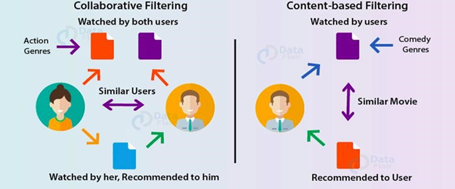

Users- They are the one who uses these services or acts as the consumer.

Items-Here these are the different sets of movies which are been recommended in a sort of zig-zag manner according to our previous searches

Three ways of performing the filtering are as follows-

* + Hybrid based filtering- is a special type of recommendation system which can be considered as the combination of the content and collaborative filtering method.
  + Content based filtering-Here the similar articles are been recommended to the user according to his previous content search.
  + Collaborative based filtering-Here the two similar user likings act as a recommender to each other. Like, we two users watch comedy movies so if a new comedy stuff appears and is watched by A user it will also be recommended to user B.

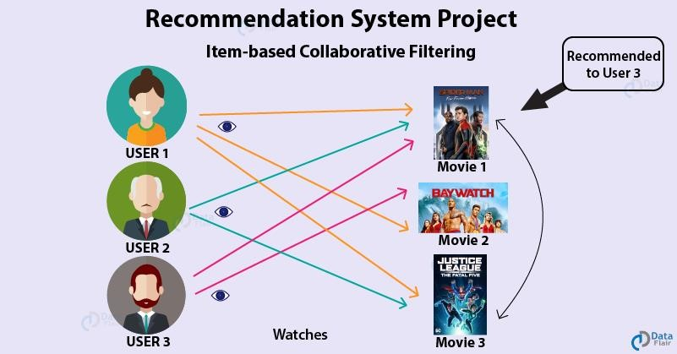

A recommender system, or a recommendation system (sometimes replacing 'system' with a synonym such as platform or engine), is a subclass of [information filtering system](https://en.wikipedia.org/wiki/Information_filtering_system) that seeks to predict the "rating" or "preference" a user would give to an item They are primarily used in commercial applications. Recommender systems are utilized in a variety of areas and are most commonly recognized as playlist generators for video and music services like [Netflix,](https://en.wikipedia.org/wiki/Netflix) [YouTube](https://en.wikipedia.org/wiki/YouTube) and [Spotify,](https://en.wikipedia.org/wiki/Spotify) product recommenders for services such as [Amazon,](https://en.wikipedia.org/wiki/Amazon_(company)) or content recommenders for social media platforms such as [Facebook](https://en.wikipedia.org/wiki/Facebook) and [Twitter.](https://en.wikipedia.org/wiki/Twitter) These systems can operate using a single input, like music, or multiple inputs within and across platforms like news, books, and search queries. There are also popular recommender systems for specific topics like restaurants and [online dating.](https://en.wikipedia.org/wiki/Online_dating) Recommender systems have also been developed to explore research articles and experts, collaborators, and financial services

These both are the recommendation engines that recommend us the movies and other related stuff based on our previous searches and watched experience. 

* Classification: It is a Supervised Learning task where output is having defined labels (discrete value).
* Regression: It is a Supervised Learning task where output is having continuous value.

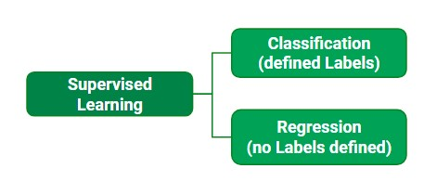

.

.

**Chapter 2**

**PROBLEM STATEMENT**

* **Online Movie Recommendation System (OMRES):**

Providing related content out of relevant and irrelevant collection of items to users of online service providers.

OMRES (Online Movie Recommendation System) aims to recommend movies to users based on user-movie (item) ratings.

**SOLUTION**

* In Online Movie Recommendation System (OMRES) for solving this type of problem by developing a Software which include movie rather than user recommended movie.
* We also link our software by telegram or YouTube that added more movie on our software.

**Chapter 3**

**SRS (Software Requirement Specification)**















 

!















 

!















 

!















 

!















 

!















 

!















 

Srs

**3.1. Introduction**

A recommendation system has become an indispensable component in various e-commerce application. Recommender System collect information about the user’s preference of different items (e.g., movies, shopping, tourism, TV) by two way, either implicitly or explicitly.

Simply put a Recommendation System is a filtration program whose prime goal is to predict the ”rating” or “preference” of a user towards a domain-specific item.

The Simple Recommendation offers generalised recommendation to every year based on movie popularity and genre.

* + 1. **Purpose**

The purpose of movie recommendation system is to filter and predict only those movies that a corresponding user is most likely want to watch. The ML algorithm for these recommendation system use the data about this user form the system’s database.

* + 1. **Scope**

Movie Recommender is a music recommendation system, which provides users movies which they may like, based on the movie that they previously saw. Every logged in user should have access to the recommender system. The system will go through the movies that user previously saw and rated, then according to those information it should provide movies to the user. The project’s main aim is to provide accurate movie recommendation to the user. This project is beneficial for the users and the companies. For user, they may find movies that they may like without consuming time and even they can encounter new movies which they like from the recommendations. For the company, they make the website more attractive, so they draw more users to the website & the system makes the users of the website spend more time online.

* + 1. **Definition:**

SRS: - Software Requirement Specification.

GUI: - Graphical User Interface.

User: - The person who will participate in system.

* + 1. **References:**
* YouTube
* Google
* W3 School
  + 1. **Overview:**

A movie recommendation system is an ML based approach to filtering or predicting the users’ s film preferences based on their past choices and behaviour.

* 1. **The Overall Description**

The basic concept behind a movie recommendation system is quite simple. It‘s an advanced filtration mechanism that predicts the possible movie choices of the concerned user and their preferences towards a domain-specific items aka movie. It is based on Content based methods on the similarity of movie attributes. Using this type of recommender system, if a user watches one movie, similar movies are recommended.

* + 1. **Product Perspective:**

In this husting world, entertainment is a necessity for each one of us to refresh our mood and energy. Entertainment regains our confidence for work and we can work more enthusiastically. for revitalizing ourselves, we can listen to our preferred music or can watch movies of our choices. For watching favourable movie online we can utilize movie recommendation systems, which are more reliable.

1. **System Interface**

* Operating System: windows
* Platform: Chrome/Edge/Opera mini
* Distributed database.

1. **Hardware Interface**

* Since the application must run over the internet, this brings out the requirements of a network interface on the device. It requires valid internet connection or wi-fi.
* Processor:- intel core i3

1. **Software Interface**

Python 3 will be used as the predominant programming language for this project. Since the project is based on Machine Learning Python is the clear as it has build modules for handling & cleansing data e.g. Pandas and numpy and also for training the recommendation model.

1. **Communication Interfaces**

The movie recommender system shall use the HTTP protocol for communication over the internet and for the internet communication will be through TCP/IP protocol suite.

1. **Memory**

At the beginning of the Recommendation System project, we will be using our local computers. Therefore minimum 2GB(64-bit) RAM and 20 GB (64-bit) hard disk space will be needed.

1. **Operations**

Our web Services makes recommendation even if the user has not played any tracks. This is cold start & the recommendation operation related to this phase are not user specific. For gaining better recommendation user shall search, listen or download tracks.

1. **Site Adaptions Requirements**

We are going to study with big data on this project. However, our local computers restrict us & we cannot deal with big data. Therefore, we need to deploy our project on a web server.

* + 1. **Product Function**
  1. **Users:**
* Generate Data
* Get Recommendation
  1. **Interagent:**
* Get Recommendation
* Provide Dataset
* Update Dataset
* Integrate Web Services
  + 1. **User Characteristics**

The main aim of this product is to eliminate the tedious task of searching through a plethora of movies in a collection and hence save the user time by curating a list of movies the user might like based on the user’s preference, hence the product is not class oriented. People of every age group can use this product.

* + 1. **Constraint:**

Recommendation system suffers from three major problem: cold start, huge data and sparsity. It needs enough users to find a match.

* + 1. **Assumption for dependencies**

Our end product is planned to be a REST- compliant Web service. There must be Internet Connection.

* 1. **Specific Requirements:**
* Functional Requirements
* Non- Functional Requirements
  + 1. **Functional Requirements**
* Applicant’s dashboard page.
* A page with list of movies
* A feature to filter and organize movies based on rating, genre and other description.
* A feature to enable applicants to explore different movies based on heir preferences.

Database: It should be based on past preferences of the user will be created.

Algorithm: It will capture preferences & suggest movies based on it.

* + 1. **Performance Requirements**

Performance of making recommendation and updating this recommendation is very important issue because we are aiming to make the system real-timed. The system should have enough speed that users of the system cannot realize the processing of data.

* + 1. **Design Constraints:**
* HTML, CSS, Python for the development of user interface

**3.3.4**  **Logical Database Requirements**

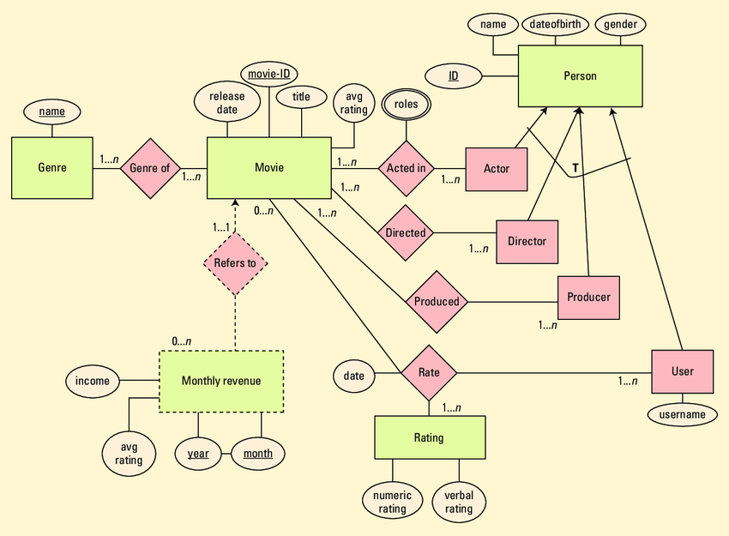

Entity: A real world object.

Relationship: It is a reason for Securityassociating two entity types.

Attributes: It is a property or characteristics of an entity that is of interest to organization.

**3.3.5 Software System attributes:**

* Correctness
* Usability
* Maintainability
* Availability

**Chapter 4**

**System Architecture**

* 1. **. Tools and Techniques identified to carry out the proposed work**
* Visual Studio Code
* Jupyter Notebook
* Python
* HTML
* CSS
* Machine Learning

1. **Visual Studio Code**
   1. It is the most popular code editor that support multiple languages(like-java, python, JavaScript, C, C++ and many more). In this project we use this code editor.
   2. As it provides many wonderful extensions to help us code easily.
   3. Visual Studio Code combines the simplicity of a source code editor with powerful developer tooling, like IntelliSense code completion and debugging.
   4. First and foremost, it is an editor that gets out of your way. The delightfully frictionless edit-build-debug cycle means less time fiddling with your environment, and more time executing on your ideas.
2. **Jupyter Notebook**
3. The Jupyter Notebook App is a server-client application that allows editing and running notebook document via a web browser.
4. The Jupyter Notebook App can be executed on a local desktop requiring no internet access (as described in this document) or can be installed on a remote server and accessed through the internet.
5. **Python**
6. Python is a high level language, general purpose programming language.
7. Its design philosophy emphasizes code readability with the use of significant identation.
8. Python is dynamically-typed and garbage-collected.
9. It supports multiple programming paradigms, including structured (particularly procedural), object-oriented and functional programming**.**
10. **HTML**
    1. The **HyperText Markup Language** or **HTML** is the standard mark up language for documents designed to be displayed in a web browser..
    2. It can be assisted by technologies such as Cascading Style Sheets (CSS) and scripting languages such as JavaScript.
    3. Web browsers receive HTML documents from a web server or from local storage and render the documents into multimedia web pages.
11. **CSS**
    1. **Cascading Style Sheets** (**CSS**) is a style sheet language used for describing the presentation of a document written in a markup language such as HTML or XML (including XML dialects such as SVG, MathML or XHTML).[]](https://en.wikipedia.org/wiki/CSS#cite_note-1)
    2. CSS is a cornerstone technology of the World Wide Web, alongside HTML and JavaScript.
    3. CSS is designed to enable the separation of content and presentation, including layout, colors, and fonts**.**
12. **Machine Learning**
    1. **Machine learning** (**ML**) is a field of inquiry devoted to understanding and building methods that 'learn', that is, methods that leverage data to improve performance on some set of tasks.
    2. It is seen as a part of artificial intelligence. Machine learning algorithms build a model based on sample data, known as training data, in order to make predictions or decisions without being explicitly programmed to do so.
    3. Machine learning algorithms are used in a wide variety of applications, such as in medicine, email filtering, speech recognition, agriculture, and computer vision, where it is difficult or unfeasible to develop conventional algorithms to perform the needed tasks

**4.2. Architectural design for proposed work**

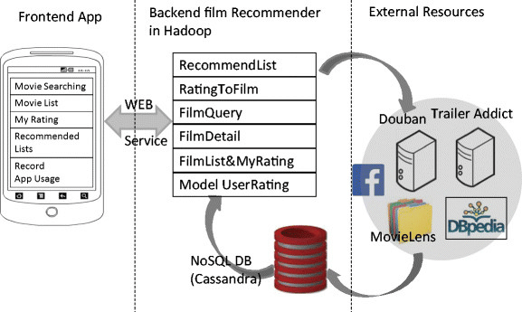

**4.3 Use Case Diagram**

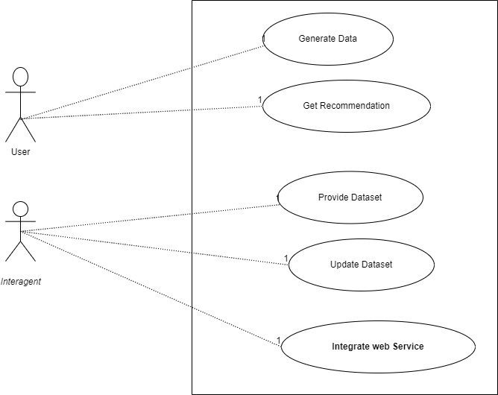

**Role of the Actor:-**

* User search the movie of their interest.
* User get recommendation of the movie as it search previous movie or according to rating of the movie.
* Integrant update the data in the data set as the new movie will release.
* Integrant provide the dataset to the

**4.5. Any State, sequence, collaboration, and flow diagrams.**

**4.5.1 State Diagram-**

**Server**

**Rate Track**

**Search Track**

**User Input**

**Generation**

**Database Update**

**Smilarity**

**Construction**

**Get**

**Recommendation**

**Display Output**

Recommendation State

Traverse Graph Database

[

Similar Nodes Found

]

Add to Recommendation List

New Data [Data Valid]/ Insert Data

Big Data]/Handle

[

Big Data

[

Valid User

]

**Train Dataset**

Algorithm Evaluation State

Apply Alogrithm

**RMSE**

**< 0.7]**

**[**

**> 0.7]**

**[**

**RMSE**

**Success**

**Fail**

**Check Result**

**Get Recommendation For Test Data**

A **state diagram** is used to represent the condition of the system or part of the system at finite instances of time. It’s a **behavioral** diagram and it represents the behavior using finite state transitions. State diagrams are also referred to as **State machines** and **State-chart Diagrams**. These terms are often used interchangeably. So simply, a state diagram is used to model the dynamic behavior of a class in response to time and changing external stimuli. We can say that each and every class has a state but we don’t model every class using State diagrams. We prefer to model the states with three or more states.

* We use it to state the events responsible for change in state (we do not show what processes cause those events).
* We use it to model the dynamic behavior of the system.
* To understand the reaction of objects/classes to internal or external stimuli.

**4.5.2 Sequence Diagram-**

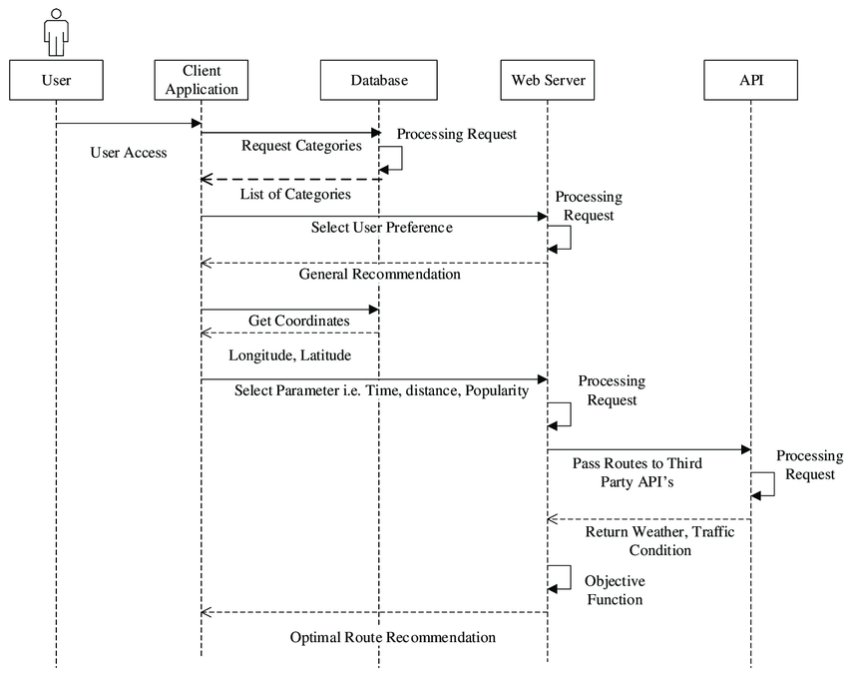

Thisis the **UML Sequence Diagram of Movie Recommendation System** Which shows the user interest movie recommend. In this user search the movie according to their intrest.The instance of Class Objects involved on this UML Sequence Diagram of Movie Recommendation System are as follows:

* User Object
* Client Application Object
* Database Object
* Web Server Object
* API Object

**4.5.3 Collaboration Diagram-**

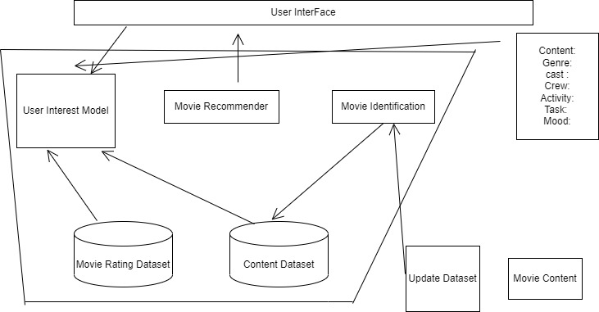

The collaboration diagram is used to show the relationship between the objects in a system. Both the sequence and the collaboration diagrams represent the same information but differently. Instead of showing the flow of messages, it depicts the architecture of the object residing in the system as it is based on object-oriented programming. An object consists of several features. Multiple objects present in the system are connected to each other. The collaboration diagram, which is also known as a communication diagram, is used to portray the object's architecture in the system.

The collaborations are used when it is essential to depict the relationship between the object. Both the sequence and collaboration diagrams represent the same information, but the way of portraying it quite different. The collaboration diagrams are best suited for analyzing use cases.

**4.5.4 Flow Diagrams**

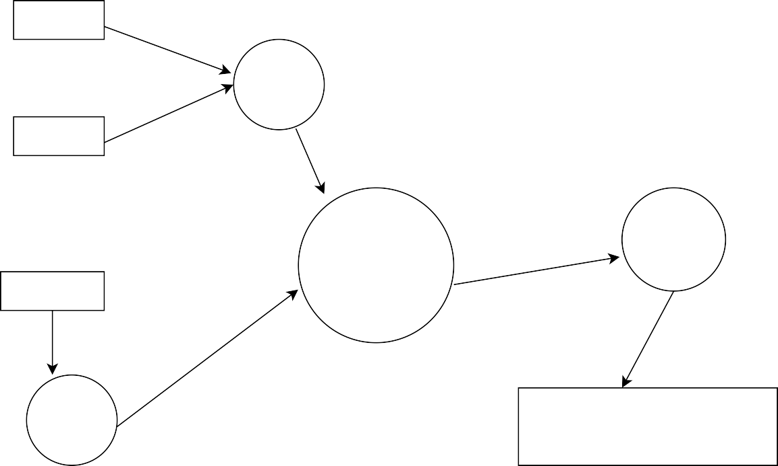

USER

User Profile

RATING

Virtual User Generation

PRODUCT

Recommender System

Product Profile

Recommendation Generated

A data-flow diagram is a way of representing a flow of data through a process or a system. The DFD also provide information about the outputs and inputs of each entity and the process itself. A DFD has no control flow- there are no decision rule and no loops. Specific operations based on the data can be represented by flowchart.

**Chapter 5**

**Database Design**

**5.1. Home**

In this section, we will design the **Home** to get recommendation. Below mentioned is the description of all the columns of the Home.

|  |  |
| --- | --- |
| **Logo** | Logo of the website |
| **Introduction** | Introduction of website |
| **Recommendation** | By clicking on this we go on recommendation page |

**5.2 Recommendation**

In this section, we will design the **Recommendation table**. In this user search the movie according to their interest and submit the movie name.

|  |  |
| --- | --- |
| **Search Bar** | User search the movie. |
| **Submit** | User submit the movie for search. |
| **Recommended**  **movie** | Recommended movies according to the user interest. |

**5.3 About**

In this section, we will design the **Information About Team**. We tell about our team.

**5.4. Contact**

In this section, we will design the page to the user for contact the team for any query, or for any suggestion.

**Chapter 6**

**Coding**

**Frontend**

**App.py**

from flask import Flask, request, render_template

import pickle

import requests

import pandas as pd

from patsy import dmatrices

movies = pickle.load(open('model/movie.pkl', 'rb'))

similarity = pickle.load(open('model/similarity.pkl', 'rb'))

def fetch_poster(movies_id):

url = "https://api.themoviedb.org/3/movie/550?api_key=f26f00586aa6ba538f35f141093402c4".format(movie_id)

data = requests.get(url)

data = data.json()

poster_path = data['poster_path']

full_path = "https://image.tmdb.org/t/p/w500/kqjL17yufvn9OVLyXYpvtyrFfak.jpg" + poster_path

return full_path

def recommend(movie):

index = [movies['title'] == movie].index[0]

distances = sorted(list(enumerate(similarity[index])), reverse= True, key=lambda x: x[1])

recommend_movies_name = []

recommend_movies_poster = []

for i in distances[1:6]:

movie_id = movie.iloc[i[0]].movie_id

recommend_movies_poster.append(fetch_poster(movie_id))

recommend_movies_name.append(movies.iloc[i[0]].title)

return recommend_movies_name, recommend_movies_poster

app = Flask(__name__)

@app.route('/')

def home():

return render_template("index.html")

@app.route('/about')

def about():

return render_template("about.html")

@app.route('/contact')

def contact():

return render_template("contact.html")

@app.route('/recommendation', methods = ['GET', 'POST'])

def recommendation():

movies_list = movies['title'].values

status = False

if request.method == "POST":

try:

if request.form:

movies_name = request.form['movies']

print(movies_name)

print(recommend_movies_poster)

recommend_movies_name,recommend_movies_poster = recommend(movies_name)

print(recommend_movies_name)

status = True

return render_template("prediction.html", movies_name = recommend_movies_name, poster = recommend_movies_poster, movies_list = movies_list, status = status)

except Exception as e:

error = {'error':e}

return render_template("prediction.html", error = error, movies_list = movies_list, status = status)

else:

return render_template("prediction.html", movies_list = movies_list, status = status)

if __name__ == '__main__':

app.debug = True

app.run()

**Home page**

<!doctype html>

<html lang="en">

<head>

<meta charset="utf-8">

<meta name="viewport" content="width=device-width, initial-scale=1">

<title>Movie Recommendation System</title>

<script src="https://cdn.tailwindcss.com"></script>

<link href="https://cdn.jsdelivr.net/npm/bootstrap@5.2.2/dist/css/bootstrap.min.css" rel="stylesheet" integrity="sha384-Zenh87qX5JnK2Jl0vWa8Ck2rdkQ2Bzep5IDxbcnCeuOxjzrPF/et3URy9Bv1WTRi" crossorigin="anonymous">

<style>

.backImg {

background-image: url("../static/project image.jpeg");

background-repeat: no-repeat;

background-size: 100% 90vh;

color: aliceblue

}

.backGrade-lf {

background: rgba(0,0,0,.4);

background-image: linear-gradient(90deg,rgba(0,0,0,.5) 0,transparent 80%,rgba(0,0,0,.5));

/* background-size: 100% 90vh; */

position: absolute;

top: 0;

left : 0;

right : 0;

bottom: 0;

z-index: -1;

}

.backGrade-tb {

background: rgba(0,0,0,.4);

background-image: linear-gradient(180deg,rgba(0,0,0,.3) 0,transparent 80%,rgba(0,0,0,.3));

/* background-size: 100% 90vh; */

position: absolute;

top: 0;

left : 0;

right : 0;

bottom: 0;

z-index: -1;

}

.white{

color: white;

}

.red{

color: rgb(201, 15, 15);

}

.logo{

width: 45px;

height: 45px;

}

.sub-cont {

margin: 0 23em 2em 23em;

text-align: justify;

}

</style>

</head>

<body class="backImg">

<div class="backGrade-tb">

</div>

<div class="backGrade-lf"></div>

<header class="text-gray-600 body-font -my-8">

<div class="container mx-auto flex flex-wrap p-5 flex-col md:flex-row items-center">

<a class="flex title-font font-medium items-center white mb-4 md:mb-0">

<img src="../static/logo copy.jpg" class="logo" alt="MRS" />

<a href="/"><span class="ml-3 white text-xl">MRS</span></a>

</a>

<nav class="md:ml-auto flex flex-wrap items-center text-base justify-center">

<a href ="/" class="mr-5 white hover:text-gray-900">Home</a>

<a href ="/about" class="mr-5 white hover:text-gray-900">About</a>

<a href ="/contact" class="mr-5 white hover:text-gray-900">Contact Us</a>

<a href ="/recommendation" class="mr-5 white hover:text-gray-900">Recommendation</a>

</nav>

</div>

</header>

<hr>

<section class="text-gray-600 body-font -my-8">

<div class="container flex py-24 flex-col items-center">

<div class="flex flex-col text-center w-full mb-12"><br>

<h1 class="sm:text-3xl text-2xl font-medium title-font mb-4 white ">Movie Recommendation System

</h1>

<p class="leading-relaxed text-white sub-cont">A movie recommendation system, or a movie recommender system, is an ML-based approach to filtering or predicting the users' film preferences based on their past choices and behavior. It's an advanced filteration mechanism that predicts the possible movie choices of the concerned user and their preferences towards a domain-specific item, aka movie.</p>

<div class="flex justify-center">

<a href="/recommendation"><button class="inline-flex text-white bg-green-500 border-0 py-2 px-6 focus:outline-none hover:bg-green-600 rounded text-lg">Recommendation</button></a.href>

</div>

</div>

<div class="lg:max-w-lg lg:w-full md:w-1/2 w-5/6">

</div>

</div>

</section>

</body>

</html>

**About**

<!doctype html>

<html lang="en">

<head>

<meta charset="utf-8">

<meta name="viewport" content="width=device-width, initial-scale=1">

<title>Movie Recommendation System</title>

<script src="https://cdn.tailwindcss.com"></script>

<link href="https://cdn.jsdelivr.net/npm/bootstrap@5.2.2/dist/css/bootstrap.min.css" rel="stylesheet" integrity="sha384-Zenh87qX5JnK2Jl0vWa8Ck2rdkQ2Bzep5IDxbcnCeuOxjzrPF/et3URy9Bv1WTRi" crossorigin="anonymous">

<style>

.backImg {

background-image: url("../static/project image.jpeg");

background-repeat: no-repeat;

background-size: 100% 90vh;

color: aliceblue

}

.backGrade-lf {

background: rgba(0,0,0,.4);

background-image: linear-gradient(90deg,rgba(0,0,0,.5) 0,transparent 80%,rgba(0,0,0,.5));

position: absolute;

top: 0;

left : 0;

right : 0;

bottom: 0;

z-index: -1;

}

.backGrade-tb {

background: rgba(0,0,0,.4);

background-image: linear-gradient(180deg,rgba(0,0,0,.3) 0,transparent 80%,rgba(0,0,0,.3));

position: absolute;

top: 0;

left : 0;

right : 0;

bottom: 0;

z-index: -1;

}

.white{

color: white;

}

.red{

color: rgb(201, 15, 15);

}

.logo{

width: 45px;

height: 45px;

}

.py24{

padding-top: 6rem;

padding-bottom: 5rem;

}

.mb20 {

margin-bottom: 2rem;

}

.lg\:w-1\/3 {

width: 33%;

}

.p4{

padding: 1rem 0 0 0;

}

.sar{

justify-content: space-between;

padding: 0 2rem;

}

</style>

</head>

<body class="backImg">

<div class="backGrade-tb">

</div>

<div class="backGrade-lf"></div>

<header class="text-gray-600 body-font -my-8">

<div class="container mx-auto flex flex-wrap p-5 flex-col md:flex-row items-center">

<a class="flex title-font font-medium items-center text-gray-900 mb-4 md:mb-0">

<img src="../static/logo copy.jpg" class="logo" alt="MRS" />

<a href="/"><span class="ml-3 white text-xl">MRS</span></a>

</a>

<nav class="md:ml-auto flex flex-wrap items-center text-base justify-center">

<a href ="/" class="mr-5 white hover:text-gray-900">Home</a>

<a href ="/about" class="mr-5 white hover:text-gray-900">About</a>

<a href ="/contact" class="mr-5 white hover:text-gray-900">Contact Us</a>

<a href ="/recommendation" class="mr-5 white hover:text-gray-900">Recommendation</a>

</nav>

</div>

</header>

<section class="text-gray-600 body-font -my-8">

<div class="container px-5 py24 mx-auto">

<div class="xl:w-1/2 lg:w-3/4 w-full mx-auto text-center">

<svg xmlns="http://www.w3.org/2000/svg" fill="currentColor" class="inline-block w-8 h-8 text-gray-400 mb-8" viewBox="0 0 975.036 975.036">

<path d="M925.036 57.197h-304c-27.6 0-50 22.4-50 50v304c0 27.601 22.4 50 50 50h145.5c-1.9 79.601-20.4 143.3-55.4 191.2-27.6 37.8-69.399 69.1-125.3 93.8-25.7 11.3-36.8 41.7-24.8 67.101l36 76c11.6 24.399 40.3 35.1 65.1 24.399 66.2-28.6 122.101-64.8 167.7-108.8 55.601-53.7 93.7-114.3 114.3-181.9 20.601-67.6 30.9-159.8 30.9-276.8v-239c0-27.599-22.401-50-50-50zM106.036 913.497c65.4-28.5 121-64.699 166.9-108.6 56.1-53.7 94.4-114.1 115-181.2 20.6-67.1 30.899-159.6 30.899-277.5v-239c0-27.6-22.399-50-50-50h-304c-27.6 0-50 22.4-50 50v304c0 27.601 22.4 50 50 50h145.5c-1.9 79.601-20.4 143.3-55.4 191.2-27.6 37.8-69.4 69.1-125.3 93.8-25.7 11.3-36.8 41.7-24.8 67.101l35.9 75.8c11.601 24.399 40.501 35.2 65.301 24.399z"></path>

</svg>

<p class="leading-relaxed text-white">Our team member name is <b>Yash Dwivedi, Pragya Bansal and Shuchi Gupta</b> from <b>Ajay Kumar Garg Engineering College, Ghaziabad</b> pursuing <b> Master of Computer Application </b>

</div>

<span class="inline-block h-1 w-10 rounded bg-white mt-8 mb-6" style="margin-left: 48.5%;"></span>

</div>

</section>

<section class="text-gray-600 body-font -my-8">

<div class="flex flex-col text-center w-full mb20">

<h1 class="text-2xl font-medium title-font red mb-4 text-red tracking-widest">OUR TEAM</h1>

</div>

</div>

<div class="flex flex-wrap sar">

<div class="p4 lg\:w-1\/3">

<div class="h-full flex sm:flex-row flex-col items-center sm:justify-start justify-center text-center sm:text-left">

<img alt="team" class="flex-shrink-0 rounded-lg w-48 h-48 object-cover object-center sm:mb-0 mb-4" src="../static/Yash.jpg">

<div class="flex-grow sm:pl-8">

<h2 class="title-font font-medium text-lg text white">Yash Dwivedi</h2>

<h3 class="text white mb-3">Developer</h3>

<p class="mb-4">MCA Student</p>

<span class="inline-flex">

<a class="text-gray-500">

<svg fill="none" stroke="currentColor" stroke-linecap="round" stroke-linejoin="round" stroke-width="2" class="w-5 h-5" viewBox="0 0 24 24">

<path d="M18 2h-3a5 5 0 00-5 5v3H7v4h3v8h4v-8h3l1-4h-4V7a1 1 0 011-1h3z"></path>

</svg>

</a>

<a class="ml-2 text-gray-500">

<svg fill="none" stroke="currentColor" stroke-linecap="round" stroke-linejoin="round" stroke-width="2" class="w-5 h-5" viewBox="0 0 24 24">

<path d="M23 3a10.9 10.9 0 01-3.14 1.53 4.48 4.48 0 00-7.86 3v1A10.66 10.66 0 013 4s-4 9 5 13a11.64 11.64 0 01-7 2c9 5 20 0 20-11.5a4.5 4.5 0 00-.08-.83A7.72 7.72 0 0023 3z"></path>

</svg>

</a>

<a class="ml-2 text-gray-500">

<svg fill="none" stroke="currentColor" stroke-linecap="round" stroke-linejoin="round" stroke-width="2" class="w-5 h-5" viewBox="0 0 24 24">

<path d="M21 11.5a8.38 8.38 0 01-.9 3.8 8.5 8.5 0 01-7.6 4.7 8.38 8.38 0 01-3.8-.9L3 21l1.9-5.7a8.38 8.38 0 01-.9-3.8 8.5 8.5 0 014.7-7.6 8.38 8.38 0 013.8-.9h.5a8.48 8.48 0 018 8v.5z"></path>

</svg>

</a>

</span>

</div>

</div>

</div>

<div class="p4 lg\:w-1\/3">

<div class="h-full flex sm:flex-row flex-col items-center sm:justify-start justify-center text-center sm:text-left">

<img alt="team" class="flex-shrink-0 rounded-lg w-48 h-48 object-cover object-center sm:mb-0 mb-4" src="../static/Pragya.jpeg">

<div class="flex-grow sm:pl-8">

<h2 class="title-font font-medium text-lg text white">Pragya Bansal</h2>

<h3 class="text white mb-3">Designer</h3>

<p class="mb-4">MCA Student</p>

<span class="inline-flex">

<a class="text-gray-500">

<svg fill="none" stroke="currentColor" stroke-linecap="round" stroke-linejoin="round" stroke-width="2" class="w-5 h-5" viewBox="0 0 24 24">

<path d="M18 2h-3a5 5 0 00-5 5v3H7v4h3v8h4v-8h3l1-4h-4V7a1 1 0 011-1h3z"></path>

</svg>

</a>

<a class="ml-2 text-gray-500">

<svg fill="none" stroke="currentColor" stroke-linecap="round" stroke-linejoin="round" stroke-width="2" class="w-5 h-5" viewBox="0 0 24 24">

<path d="M23 3a10.9 10.9 0 01-3.14 1.53 4.48 4.48 0 00-7.86 3v1A10.66 10.66 0 013 4s-4 9 5 13a11.64 11.64 0 01-7 2c9 5 20 0 20-11.5a4.5 4.5 0 00-.08-.83A7.72 7.72 0 0023 3z"></path>

</svg>

</a>

<a class="ml-2 text-gray-500">

<svg fill="none" stroke="currentColor" stroke-linecap="round" stroke-linejoin="round" stroke-width="2" class="w-5 h-5" viewBox="0 0 24 24">

<path d="M21 11.5a8.38 8.38 0 01-.9 3.8 8.5 8.5 0 01-7.6 4.7 8.38 8.38 0 01-3.8-.9L3 21l1.9-5.7a8.38 8.38 0 01-.9-3.8 8.5 8.5 0 014.7-7.6 8.38 8.38 0 013.8-.9h.5a8.48 8.48 0 018 8v.5z"></path>

</svg>

</a>

</span>

</div>

</div>

</div>

<div class="p4 lg\:w-1\/3">

<div class="h-full flex sm:flex-row flex-col items-center sm:justify-start justify-center text-center sm:text-left">

<img alt="team" class="flex-shrink-0 rounded-lg w-48 h-48 object-cover object-center sm:mb-0 mb-4" src="../static/Shuchi2.jpeg">

<div class="flex-grow sm:pl-8">

<h2 class="title-font font-medium text-lg text text-gray-800">Shuchi Gupta</h2>

<h3 class="text-gray-600 mb-3">Developer</h3>

<p class="mb-4">MCA Student</p>

<span class="inline-flex">

<a class="text-gray-500">

<svg fill="none" stroke="currentColor" stroke-linecap="round" stroke-linejoin="round" stroke-width="2" class="w-5 h-5" viewBox="0 0 24 24">

<path d="M18 2h-3a5 5 0 00-5 5v3H7v4h3v8h4v-8h3l1-4h-4V7a1 1 0 011-1h3z"></path>

</svg>

</a>

<a class="ml-2 text-gray-500">

<svg fill="none" stroke="currentColor" stroke-linecap="round" stroke-linejoin="round" stroke-width="2" class="w-5 h-5" viewBox="0 0 24 24">

<path d="M23 3a10.9 10.9 0 01-3.14 1.53 4.48 4.48 0 00-7.86 3v1A10.66 10.66 0 013 4s-4 9 5 13a11.64 11.64 0 01-7 2c9 5 20 0 20-11.5a4.5 4.5 0 00-.08-.83A7.72 7.72 0 0023 3z"></path>

</svg>

</a>

<a class="ml-2 text-gray-500">

<svg fill="none" stroke="currentColor" stroke-linecap="round" stroke-linejoin="round" stroke-width="2" class="w-5 h-5" viewBox="0 0 24 24">

<path d="M21 11.5a8.38 8.38 0 01-.9 3.8 8.5 8.5 0 01-7.6 4.7 8.38 8.38 0 01-3.8-.9L3 21l1.9-5.7a8.38 8.38 0 01-.9-3.8 8.5 8.5 0 014.7-7.6 8.38 8.38 0 013.8-.9h.5a8.48 8.48 0 018 8v.5z"></path>

</svg>

</a>

</span>

</div>

</div>

</div>

</div>

</div>

</section>

<script src="https://cdn.jsdelivr.net/npm/bootstrap@5.2.2/dist/js/bootstrap.bundle.min.js" integrity="sha384-OERcA2EqjJCMA+/3y+gxIOqMEjwtxJY7qPCqsdltbNJuaOe923+mo//f6V8Qbsw3" crossorigin="anonymous"></script>

</body>

</html>

**Contact Us**

<!doctype html>

<html lang="en">

<head>

<meta charset="utf-8">

<meta name="viewport" content="width=device-width, initial-scale=1">

<title>Movie Recommendation System</title>

<script src="https://cdn.tailwindcss.com"></script>

<link href="https://cdn.jsdelivr.net/npm/bootstrap@5.2.2/dist/css/bootstrap.min.css" rel="stylesheet" integrity="sha384-Zenh87qX5JnK2Jl0vWa8Ck2rdkQ2Bzep5IDxbcnCeuOxjzrPF/et3URy9Bv1WTRi" crossorigin="anonymous">

<style>

.backImg {

background-image: url("../static/project image.jpeg");

background-repeat: no-repeat;

background-size: 100% 90vh;

color: aliceblue

}

.backGrade-lf {

background: rgba(0,0,0,.4);

background-image: linear-gradient(90deg,rgba(0,0,0,.5) 0,transparent 80%,rgba(0,0,0,.5));

position: absolute;

top: 0;

left : 0;

right : 0;

bottom: 0;

z-index: -1;

}

.backGrade-tb {

background: rgba(0,0,0,.4);

background-image: linear-gradient(180deg,rgba(0,0,0,.3) 0,transparent 80%,rgba(0,0,0,.3));

position: absolute;

top: 0;

left : 0;

right : 0;

bottom: 0;

z-index: -1;

}

.white{

color: white;

}

.red{

color: rgb(201, 15, 15);

}

.blue{

color:blue;

}

.white{

color: rgb(255, 255, 255);

}

.logo{

width: 45px;

height: 45px;

}

</style>

</head>

<body class="backImg">

<div class="backGrade-tb">

</div>

<div class="backGrade-lf"></div>

<header class="text-gray-600 body-font -my-8">

<div class="container mx-auto flex flex-wrap p-5 flex-col md:flex-row items-center">

<a class="flex title-font font-medium items-center text-gray-900 mb-4 md:mb-0">

<img src="../static/logo copy.jpg" class="logo" alt="MRS" />

<a href="/"><span class="ml-3 white text-xl">MRS</span></a>

</a>

<nav class="md:ml-auto flex flex-wrap items-center text-base justify-center">

<a href ="/" class="mr-5 white hover:text-gray-900">Home</a>

<a href ="/about" class="mr-5 white hover:text-gray-900">About</a>

<a href ="/contact" class="mr-5 white hover:text-gray-900">Contact Us</a>

<a href ="/recommendation" class="mr-5 white hover:text-gray-900">Recommendation</a>

</nav>

</div>

</header>

<section class="text-gray-600 body-font relative -my-8">

<div class="container px-5 mx-auto" style="padding-top: 6rem;">

<div class="flex flex-col text-center w-full mb-12">

<h1 class="sm:text-3xl text-2xl font-medium title-font mb-4 text-white">Contact Us</h1>

<p class="lg:w-2/3 white mx-auto leading-relaxed text-base">For any further query contect with this :</p>

</div>

<div class="lg:w-1/2 md:w-2/3 mx-auto">

<div class="flex flex-wrap -m-2">

<div class="p-2 w-1/2">

<div class="relative">

<label for="name" class="leading-7 text-sm text white">Name</label>

<input type="text" id="name" name="name" class="w-full bg white bg-opacity-50 rounded border border-gray-300 focus:border-green-500 focus:bg-white focus:ring-2 focus:ring-green-200 text-base outline-none text-gray-700 py-1 px-3 leading-8 transition-colors duration-200 ease-in-out">

</div>

</div>

<div class="p-2 w-1/2">

<div class="relative">

<label for="email" class="leading-7 text-sm text white">Email address or phone number</label>

<input type="email" id="email" name="email" class="w-full bg white bg-opacity-50 rounded border border-gray-300 focus:border-green-500 focus:bg-white focus:ring-2 focus:ring-green-200 text-base outline-none text-gray-700 py-1 px-3 leading-8 transition-colors duration-200 ease-in-out">

</div>

</div>

<div class="p-2 w-full">

<div class="relative">

<label for="message" class="leading-7 text-sm text white">Message</label>

<textarea id="message" name="message" class="w-full bg white bg-opacity-50 rounded border border-gray-300 focus:border-green-500 focus:bg-white focus:ring-2 focus:ring-green-200 h-32 text-base outline-none text-gray-700 py-1 px-3 resize-none leading-6 transition-colors duration-200 ease-in-out"></textarea>

</div>

</div>

<div class="p-2 w-full">

<button class="flex mx-auto text-white bg-green-500 border-0 py-2 px-8 focus:outline-none hover:bg-green-600 rounded text-lg">Submit</button>

</div>

<div class="p-2 w-full pt-8 mt-8 border-t border-gray-200 text-center">

<a class="text red">example@gmail.com</a>

<br>

<span class="inline-flex">

<a class="text blue">

<svg fill="currentColor" stroke-linecap="round" stroke-linejoin="round" stroke-width="2" class="w-5 h-5" viewBox="0 0 24 24">

<path d="M18 2h-3a5 5 0 00-5 5v3H7v4h3v8h4v-8h3l1-4h-4V7a1 1 0 011-1h3z"></path>

</svg>

</a>

<a class="ml-4 text-gray-500">

<svg fill="currentColor" stroke-linecap="round" stroke-linejoin="round" stroke-width="2" class="w-5 h-5" viewBox="0 0 24 24">

<path d="M23 3a10.9 10.9 0 01-3.14 1.53 4.48 4.48 0 00-7.86 3v1A10.66 10.66 0 013 4s-4 9 5 13a11.64 11.64 0 01-7 2c9 5 20 0 20-11.5a4.5 4.5 0 00-.08-.83A7.72 7.72 0 0023 3z"></path>

</svg>

</a>

<a class="ml-4 text red">

<svg fill="none" stroke="currentColor" stroke-linecap="round" stroke-linejoin="round" stroke-width="2" class="w-5 h-5" viewBox="0 0 24 24">

<rect width="20" height="20" x="2" y="2" rx="5" ry="5"></rect>

<path d="M16 11.37A4 4 0 1112.63 8 4 4 0 0116 11.37zm1.5-4.87h.01"></path>

</svg>

</a>

<a class="ml-4 text-gray-500">

<svg fill="currentColor" stroke-linecap="round" stroke-linejoin="round" stroke-width="2" class="w-5 h-5" viewBox="0 0 24 24">

<path d="M21 11.5a8.38 8.38 0 01-.9 3.8 8.5 8.5 0 01-7.6 4.7 8.38 8.38 0 01-3.8-.9L3 21l1.9-5.7a8.38 8.38 0 01-.9-3.8 8.5 8.5 0 014.7-7.6 8.38 8.38 0 013.8-.9h.5a8.48 8.48 0 018 8v.5z"></path>

</svg>

</a>

</span>

</div>

</div>

</div>

</div>

</section>

<script src="https://cdn.jsdelivr.net/npm/bootstrap@5.2.2/dist/js/bootstrap.bundle.min.js" integrity="sha384-OERcA2EqjJCMA+/3y+gxIOqMEjwtxJY7qPCqsdltbNJuaOe923+mo//f6V8Qbsw3" crossorigin="anonymous"></script>

</body>

</html>

**Recommendation**

<!doctype html>

<html lang="en">

<head>

<meta charset="utf-8">

<meta name="viewport" content="width=device-width, initial-scale=1">

<title>Movie Recommendation System</title>

<script src="https://cdn.tailwindcss.com"></script>

<link href="https://cdn.jsdelivr.net/npm/bootstrap@5.2.2/dist/css/bootstrap.min.css" rel="stylesheet" integrity="sha384-Zenh87qX5JnK2Jl0vWa8Ck2rdkQ2Bzep5IDxbcnCeuOxjzrPF/et3URy9Bv1WTRi" crossorigin="anonymous">

<style>

.backImg {

background-image: url("../static/project image.jpeg");

background-repeat: no-repeat;

background-size: 100% 90vh;

color: aliceblue

}

.backGrade-lf {

background: rgba(0,0,0,.4);

background-image: linear-gradient(90deg,rgba(0,0,0,.5) 0,transparent 80%,rgba(0,0,0,.5));

/* background-size: 100% 90vh; */

position: absolute;

top: 0;

left : 0;

right : 0;

bottom: 0;

z-index: -1;

}

.backGrade-tb {

background: rgba(0,0,0,.4);

background-image: linear-gradient(180deg,rgba(0,0,0,.3) 0,transparent 80%,rgba(0,0,0,.3));

/* background-size: 100% 90vh; */

position: absolute;

top: 0;

left : 0;

right : 0;

bottom: 0;

z-index: -1;

}

.white{

color: white;

}

.red{

color: rgb(201, 15, 15);

}

.logo{

width: 45px;

height: 45px;

}

</style>

</head>

<body class="backImg">

<div class="backGrade-tb">

</div>

<div class="backGrade-lf"></div>

<header class="text-gray-600 body-font -my-8">

<div class="container mx-auto flex flex-wrap p-5 flex-col md:flex-row items-center">

<a class="flex title-font font-medium items-center text-gray-900 mb-4 md:mb-0">

<img src="../static/logo copy.jpg" class="logo" alt="MRS" />

<a href="/"><span class="ml-3 white text-xl">MRS</span></a>

</a>

<nav class="md:ml-auto flex flex-wrap items-center text-base justify-center">

<a href ="/" class="mr-5 white hover:text-gray-900">Home</a>

<a href ="/about" class="mr-5 white hover:text-gray-900">About</a>

<a href ="/contact" class="mr-5 white hover:text-gray-900">Contact Us</a>

<a href ="/prediction" class="mr-5 white hover:text-gray-900">Recommendation</a>

</nav>

</div>

</header>

<section class="text-gray-600 body-font"style="margin-top:180;">

<div class="container px-5 py-24 mx-auto">

<div class="flex flex-col text-center w-full mb-12">

<h1 class="sm:text-3xl text-2xl font-medium title-font mb-4 white ">Movie Recommendation System</h1>

<p class="lg:w-2/3 mx-auto leading-relaxed text white">How would you like to be contacted?</p>

<p class = "text-primary"><b>error</b></p>

<div class="row text-center">

<div class="col-md-3"></div>

<div class="center col-md-6">

<form action="/recommendation", method = "POST">

<select class="form-select" id="movies" name="movies" aria-label="Default select example">

% for j in movies_list %

<option value= "{j}">{j} </option>

% endfor %

</select><br>

<button type="submit" class="btn btn-success">Submit</button>

</form>

</div>

</div>

</section>

% if status == True %

<section class="text-gray-600 body-font"style="margin-top: -185px;">

<div class="container px-5 py-14 mx-auto">

<h2 class="sm:text-3xl text-2xl font-medium title-font mb-2 text white">Recommended Movies: </h2>

</div>

<div class="flex flex-wrap -m-3">

<div class="xl:w-1/4 md:w-1/2 p-3">

<div class="bg-gray-100 p-6 rounded-lg">

<img class="h-50 rounded w-full object-cover object-center mb-6" src="poster[0]" alt="content">

<h3 class="tracking-widest text-indigo-500 text-xs font-medium title-font">Movie Name</h3>

<h2 class="text-lg text-gray-900 font-medium title-font mb-4">{movies_name[0]}</h2>

</div>

</div>

<div class="xl:w-1/4 md:w-1/2 p-3">

<div class="bg-gray-100 p-6 rounded-lg">

<img class="h-50 rounded w-full object-cover object-center mb-6" src="poster[1]" alt="content">

<h3 class="tracking-widest text-indigo-500 text-xs font-medium title-font">Movie Name</h3>

<h2 class="text-lg text-gray-900 font-medium title-font mb-4">{movies_name[1]}</h2>

</div>

</div>

<div class="xl:w-1/4 md:w-1/2 p-3">

<div class="bg-gray-100 p-6 rounded-lg">

<img class="h-50 rounded w-full object-cover object-center mb-6" src="poster[2]" alt="content">

<h3 class="tracking-widest text-indigo-500 text-xs font-medium title-font">Movie Name</h3>

<h2 class="text-lg text-gray-900 font-medium title-font mb-4">{movies_name[2]}</h2>

</div>

</div>

<div class="xl:w-1/4 md:w-1/2 p-3">

<div class="bg-gray-100 p-6 rounded-lg">

<img class="h-50 rounded w-full object-cover object-center mb-6" src="poster[3]" alt="content">

<h3 class="tracking-widest text-indigo-500 text-xs font-medium title-font">Movie Name</h3>

<h2 class="text-lg text-gray-900 font-medium title-font mb-4">{movies_name[3]}</h2>

</div>

</div>

</div>

</div>

</div>

</section>

% endif %

<script src="https://cdn.jsdelivr.net/npm/bootstrap@5.2.2/dist/js/bootstrap.bundle.min.js" integrity="sha384-OERcA2EqjJCMA+/3y+gxIOqMEjwtxJY7qPCqsdltbNJuaOe923+mo//f6V8Qbsw3" crossorigin="anonymous"></script>

</body>

</html>

**Backend**

**Flow of ML Project**

1.Data Collection 2.Data Preprocessing 3.Model Training 4.Website 5.Deployment

**Import Libraries**

import numpy as np

import pandas as pd

**Movies Dataset**

movies = pd.read_csv('tmdb_5000_movies.csv')

movies.head()

budget genres homepage id keywords original_language original_title overview popularity production_companies production_countries release_date revenue runtime spoken_languages status tagline title vote_average vote_count

0 237000000 [{"id": 28, "name": "Action"}, {"id": 12, "nam... http://www.avatarmovie.com/ 19995 [{"id": 1463, "name": "culture clash"}, {"id":... en Avatar In the 22nd century, a paraplegic Marine is di... 150.437577 [{"name": "Ingenious Film Partners", "id": 289... [{"iso_3166_1": "US", "name": "United States o... 2009-12-10 2787965087 162.0 [{"iso_639_1": "en", "name": "English"}, {"iso... Released Enter the World of Pandora. Avatar 7.2 11800

1 300000000 [{"id": 12, "name": "Adventure"}, {"id": 14, "... http://disney.go.com/disneypictures/pirates/ 285 [{"id": 270, "name": "ocean"}, {"id": 726, "na... en Pirates of the Caribbean: At World's End Captain Barbossa, long believed to be dead, ha... 139.082615 [{"name": "Walt Disney Pictures", "id": 2}, {"... [{"iso_3166_1": "US", "name": "United States o... 2007-05-19 961000000 169.0 [{"iso_639_1": "en", "name": "English"}] Released At the end of the world, the adventure begins. Pirates of the Caribbean: At World's End 6.9 4500

2 245000000 [{"id": 28, "name": "Action"}, {"id": 12, "nam... http://www.sonypictures.com/movies/spectre/ 206647 [{"id": 470, "name": "spy"}, {"id": 818, "name... en Spectre A cryptic message from Bond’s past sends him o... 107.376788 [{"name": "Columbia Pictures", "id": 5}, {"nam... [{"iso_3166_1": "GB", "name": "United Kingdom"... 2015-10-26 880674609 148.0 [{"iso_639_1": "fr", "name": "Fran\u00e7ais"},... Released A Plan No One Escapes Spectre 6.3 4466

3 250000000 [{"id": 28, "name": "Action"}, {"id": 80, "nam... http://www.thedarkknightrises.com/ 49026 [{"id": 849, "name": "dc comics"}, {"id": 853,... en The Dark Knight Rises Following the death of District Attorney Harve... 112.312950 [{"name": "Legendary Pictures", "id": 923}, {"... [{"iso_3166_1": "US", "name": "United States o... 2012-07-16 1084939099 165.0 [{"iso_639_1": "en", "name": "English"}] Released The Legend Ends The Dark Knight Rises 7.6 9106

4 260000000 [{"id": 28, "name": "Action"}, {"id": 12, "nam... http://movies.disney.com/john-carter 49529 [{"id": 818, "name": "based on novel"}, {"id":... en John Carter John Carter is a war-weary, former military ca... 43.926995 [{"name": "Walt Disney Pictures", "id": 2}] [{"iso_3166_1": "US", "name": "United States o... 2012-03-07 284139100 132.0 [{"iso_639_1": "en", "name": "English"}] Released Lost in our world, found in another. John Carter 6.1 2124

**Credits Dataset**

credits = pd.read_csv('tmdb_5000_credits.csv')

credits.head()

movie_id title cast crew

0 19995 Avatar [{"cast_id": 242, "character": "Jake Sully", "... [{"credit_id": "52fe48009251416c750aca23", "de...

1 285 Pirates of the Caribbean: At World's End [{"cast_id": 4, "character": "Captain Jack Spa... [{"credit_id": "52fe4232c3a36847f800b579", "de...

2 206647 Spectre [{"cast_id": 1, "character": "James Bond", "cr... [{"credit_id": "54805967c3a36829b5002c41", "de...

3 49026 The Dark Knight Rises [{"cast_id": 2, "character": "Bruce Wayne / Ba... [{"credit_id": "52fe4781c3a36847f81398c3", "de...

4 49529 John Carter [{"cast_id": 5, "character": "John Carter", "c... [{"credit_id": "52fe479ac3a36847f813eaa3", "de...

movies.shape

(4803, 20)

credits.shape

(4803, 4)

**Mergeing Dataset**

movies = movies.merge(credits,on='title')

movies.head()

budget genres homepage id keywords original_language original_title overview popularity production_companies ... runtime spoken_languages status tagline title vote_average vote_count movie_id cast crew

0 237000000 [{"id": 28, "name": "Action"}, {"id": 12, "nam... http://www.avatarmovie.com/ 19995 [{"id": 1463, "name": "culture clash"}, {"id":... en Avatar In the 22nd century, a paraplegic Marine is di... 150.437577 [{"name": "Ingenious Film Partners", "id": 289... ... 162.0 [{"iso_639_1": "en", "name": "English"}, {"iso... Released Enter the World of Pandora. Avatar 7.2 11800 19995 [{"cast_id": 242, "character": "Jake Sully", "... [{"credit_id": "52fe48009251416c750aca23", "de...

1 300000000 [{"id": 12, "name": "Adventure"}, {"id": 14, "... http://disney.go.com/disneypictures/pirates/ 285 [{"id": 270, "name": "ocean"}, {"id": 726, "na... en Pirates of the Caribbean: At World's End Captain Barbossa, long believed to be dead, ha... 139.082615 [{"name": "Walt Disney Pictures", "id": 2}, {"... ... 169.0 [{"iso_639_1": "en", "name": "English"}] Released At the end of the world, the adventure begins. Pirates of the Caribbean: At World's End 6.9 4500 285 [{"cast_id": 4, "character": "Captain Jack Spa... [{"credit_id": "52fe4232c3a36847f800b579", "de...

2 245000000 [{"id": 28, "name": "Action"}, {"id": 12, "nam... http://www.sonypictures.com/movies/spectre/ 206647 [{"id": 470, "name": "spy"}, {"id": 818, "name... en Spectre A cryptic message from Bond’s past sends him o... 107.376788 [{"name": "Columbia Pictures", "id": 5}, {"nam... ... 148.0 [{"iso_639_1": "fr", "name": "Fran\u00e7ais"},... Released A Plan No One Escapes Spectre 6.3 4466 206647 [{"cast_id": 1, "character": "James Bond", "cr... [{"credit_id": "54805967c3a36829b5002c41", "de...

3 250000000 [{"id": 28, "name": "Action"}, {"id": 80, "nam... http://www.thedarkknightrises.com/ 49026 [{"id": 849, "name": "dc comics"}, {"id": 853,... en The Dark Knight Rises Following the death of District Attorney Harve... 112.312950 [{"name": "Legendary Pictures", "id": 923}, {"... ... 165.0 [{"iso_639_1": "en", "name": "English"}] Released The Legend Ends The Dark Knight Rises 7.6 9106 49026 [{"cast_id": 2, "character": "Bruce Wayne / Ba... [{"credit_id": "52fe4781c3a36847f81398c3", "de...

4 260000000 [{"id": 28, "name": "Action"}, {"id": 12, "nam... http://movies.disney.com/john-carter 49529 [{"id": 818, "name": "based on novel"}, {"id":... en John Carter John Carter is a war-weary, former military ca... 43.926995 [{"name": "Walt Disney Pictures", "id": 2}] ... 132.0 [{"iso_639_1": "en", "name": "English"}] Released Lost in our world, found in another. John Carter 6.1 2124 49529 [{"cast_id": 5, "character": "John Carter", "c... [{"credit_id": "52fe479ac3a36847f813eaa3", "de...

5 rows × 23 columns

movies.shape

(4809, 23)

**Column of Movies Dataset**

1.genres 2.keywords 3.title 4.overview 5.cast 6.crew 7.homepage 8.popularity 9.spoken language 10.tagline 11.movie_id

movies = movies[['movie_id','title','overview','genres','keywords','cast','crew']]

movies.head()

movie_id title overview genres keywords cast crew

0 19995 Avatar In the 22nd century, a paraplegic Marine is di... [{"id": 28, "name": "Action"}, {"id": 12, "nam... [{"id": 1463, "name": "culture clash"}, {"id":... [{"cast_id": 242, "character": "Jake Sully", "... [{"credit_id": "52fe48009251416c750aca23", "de...

1 285 Pirates of the Caribbean: At World's End Captain Barbossa, long believed to be dead, ha... [{"id": 12, "name": "Adventure"}, {"id": 14, "... [{"id": 270, "name": "ocean"}, {"id": 726, "na... [{"cast_id": 4, "character": "Captain Jack Spa... [{"credit_id": "52fe4232c3a36847f800b579", "de...

2 206647 Spectre A cryptic message from Bond’s past sends him o... [{"id": 28, "name": "Action"}, {"id": 12, "nam... [{"id": 470, "name": "spy"}, {"id": 818, "name... [{"cast_id": 1, "character": "James Bond", "cr... [{"credit_id": "54805967c3a36829b5002c41", "de...

3 49026 The Dark Knight Rises Following the death of District Attorney Harve... [{"id": 28, "name": "Action"}, {"id": 80, "nam... [{"id": 849, "name": "dc comics"}, {"id": 853,... [{"cast_id": 2, "character": "Bruce Wayne / Ba... [{"credit_id": "52fe4781c3a36847f81398c3", "de...

4 49529 John Carter John Carter is a war-weary, former military ca... [{"id": 28, "name": "Action"}, {"id": 12, "nam... [{"id": 818, "name": "based on novel"}, {"id":... [{"cast_id": 5, "character": "John Carter", "c... [{"credit_id": "52fe479ac3a36847f813eaa3", "de...

**Missing Value**

movies.isnull().sum()

movie_id 0

title 0

overview 3

genres 0

keywords 0

cast 0

crew 0

dtype: int64

movies.dropna(inplace=True)

movies.isnull().sum()

movie_id 0

title 0

overview 0

genres 0

keywords 0

cast 0

crew 0

dtype: int64

**Check Duplicate Data Rows**

movies.duplicated().sum()

0

**Handle Genres**

movies.head()

movie_id title overview genres keywords cast crew

0 19995 Avatar In the 22nd century, a paraplegic Marine is di... [{"id": 28, "name": "Action"}, {"id": 12, "nam... [{"id": 1463, "name": "culture clash"}, {"id":... [{"cast_id": 242, "character": "Jake Sully", "... [{"credit_id": "52fe48009251416c750aca23", "de...

1 285 Pirates of the Caribbean: At World's End Captain Barbossa, long believed to be dead, ha... [{"id": 12, "name": "Adventure"}, {"id": 14, "... [{"id": 270, "name": "ocean"}, {"id": 726, "na... [{"cast_id": 4, "character": "Captain Jack Spa... [{"credit_id": "52fe4232c3a36847f800b579", "de...

2 206647 Spectre A cryptic message from Bond’s past sends him o... [{"id": 28, "name": "Action"}, {"id": 12, "nam... [{"id": 470, "name": "spy"}, {"id": 818, "name... [{"cast_id": 1, "character": "James Bond", "cr... [{"credit_id": "54805967c3a36829b5002c41", "de...

3 49026 The Dark Knight Rises Following the death of District Attorney Harve... [{"id": 28, "name": "Action"}, {"id": 80, "nam... [{"id": 849, "name": "dc comics"}, {"id": 853,... [{"cast_id": 2, "character": "Bruce Wayne / Ba... [{"credit_id": "52fe4781c3a36847f81398c3", "de...

4 49529 John Carter John Carter is a war-weary, former military ca... [{"id": 28, "name": "Action"}, {"id": 12, "nam... [{"id": 818, "name": "based on novel"}, {"id":... [{"cast_id": 5, "character": "John Carter", "c... [{"credit_id": "52fe479ac3a36847f813eaa3", "de...

movies.iloc[0].genres

'[{"id": 28, "name": "Action"}, {"id": 12, "name": "Adventure"}, {"id": 14, "name": "Fantasy"}, {"id": 878, "name": "Science Fiction"}]'

#['Action','Adventures','Fantasy','Science fiction']

import ast

ast.literal_eval('[{"id": 28, "name": "Action"}, {"id": 12, "name": "Adventure"}, {"id": 14, "name": "Fantasy"}, {"id": 878, "name": "Science Fiction"}]')

[{'id': 28, 'name': 'Action'},

{'id': 12, 'name': 'Adventure'},

{'id': 14, 'name': 'Fantasy'},

{'id': 878, 'name': 'Science Fiction'}]

def genresconvert(obj):

L = []

for i in ast.literal_eval(obj):

L.append(i['name'])

return L

genresconvert('[{"id": 28, "name": "Action"}, {"id": 12, "name": "Adventure"}, {"id": 14, "name": "Fantasy"}, {"id": 878, "name": "Science Fiction"}]')

['Action', 'Adventure', 'Fantasy', 'Science Fiction']

movies['genres'] = movies['genres'].apply(genresconvert)

movies.head()

movie_id title overview genres keywords cast crew

0 19995 Avatar In the 22nd century, a paraplegic Marine is di... [Action, Adventure, Fantasy, Science Fiction] [{"id": 1463, "name": "culture clash"}, {"id":... [{"cast_id": 242, "character": "Jake Sully", "... [{"credit_id": "52fe48009251416c750aca23", "de...

1 285 Pirates of the Caribbean: At World's End Captain Barbossa, long believed to be dead, ha... [Adventure, Fantasy, Action] [{"id": 270, "name": "ocean"}, {"id": 726, "na... [{"cast_id": 4, "character": "Captain Jack Spa... [{"credit_id": "52fe4232c3a36847f800b579", "de...

2 206647 Spectre A cryptic message from Bond’s past sends him o... [Action, Adventure, Crime] [{"id": 470, "name": "spy"}, {"id": 818, "name... [{"cast_id": 1, "character": "James Bond", "cr... [{"credit_id": "54805967c3a36829b5002c41", "de...

3 49026 The Dark Knight Rises Following the death of District Attorney Harve... [Action, Crime, Drama, Thriller] [{"id": 849, "name": "dc comics"}, {"id": 853,... [{"cast_id": 2, "character": "Bruce Wayne / Ba... [{"credit_id": "52fe4781c3a36847f81398c3", "de...

4 49529 John Carter John Carter is a war-weary, former military ca... [Action, Adventure, Science Fiction] [{"id": 818, "name": "based on novel"}, {"id":... [{"cast_id": 5, "character": "John Carter", "c... [{"credit_id": "52fe479ac3a36847f813eaa3", "de...

**Handle Keywords**

movies.iloc[0].keywords

'[{"id": 1463, "name": "culture clash"}, {"id": 2964, "name": "future"}, {"id": 3386, "name": "space war"}, {"id": 3388, "name": "space colony"}, {"id": 3679, "name": "society"}, {"id": 3801, "name": "space travel"}, {"id": 9685, "name": "futuristic"}, {"id": 9840, "name": "romance"}, {"id": 9882, "name": "space"}, {"id": 9951, "name": "alien"}, {"id": 10148, "name": "tribe"}, {"id": 10158, "name": "alien planet"}, {"id": 10987, "name": "cgi"}, {"id": 11399, "name": "marine"}, {"id": 13065, "name": "soldier"}, {"id": 14643, "name": "battle"}, {"id": 14720, "name": "love affair"}, {"id": 165431, "name": "anti war"}, {"id": 193554, "name": "power relations"}, {"id": 206690, "name": "mind and soul"}, {"id": 209714, "name": "3d"}]'

movies['keywords'] = movies['keywords'].apply(genresconvert)

movies.head()

movie_id title overview genres keywords cast crew

0 19995 Avatar In the 22nd century, a paraplegic Marine is di... [Action, Adventure, Fantasy, Science Fiction] [culture clash, future, space war, space colon... [{"cast_id": 242, "character": "Jake Sully", "... [{"credit_id": "52fe48009251416c750aca23", "de...

1 285 Pirates of the Caribbean: At World's End Captain Barbossa, long believed to be dead, ha... [Adventure, Fantasy, Action] [ocean, drug abuse, exotic island, east india ... [{"cast_id": 4, "character": "Captain Jack Spa... [{"credit_id": "52fe4232c3a36847f800b579", "de...

2 206647 Spectre A cryptic message from Bond’s past sends him o... [Action, Adventure, Crime] [spy, based on novel, secret agent, sequel, mi... [{"cast_id": 1, "character": "James Bond", "cr... [{"credit_id": "54805967c3a36829b5002c41", "de...

3 49026 The Dark Knight Rises Following the death of District Attorney Harve... [Action, Crime, Drama, Thriller] [dc comics, crime fighter, terrorist, secret i... [{"cast_id": 2, "character": "Bruce Wayne / Ba... [{"credit_id": "52fe4781c3a36847f81398c3", "de...

4 49529 John Carter John Carter is a war-weary, former military ca... [Action, Adventure, Science Fiction] [based on novel, mars, medallion, space travel... [{"cast_id": 5, "character": "John Carter", "c... [{"credit_id": "52fe479ac3a36847f813eaa3", "de...

**Handle Cast**

movies.iloc[0].cast

'[{"cast_id": 242, "character": "Jake Sully", "credit_id": "5602a8a7c3a3685532001c9a", "gender": 2, "id": 65731, "name": "Sam Worthington", "order": 0}, {"cast_id": 3, "character": "Neytiri", "credit_id": "52fe48009251416c750ac9cb", "gender": 1, "id": 8691, "name": "Zoe Saldana", "order": 1}, {"cast_id": 25, "character": "Dr. Grace Augustine", "credit_id": "52fe48009251416c750aca39", "gender": 1, "id": 10205, "name": "Sigourney Weaver", "order": 2}, {"cast_id": 4, "character": "Col. Quaritch", "credit_id": "52fe48009251416c750ac9cf", "gender": 2, "id": 32747, "name": "Stephen Lang", "order": 3}, {"cast_id": 5, "character": "Trudy Chacon", "credit_id": "52fe48009251416c750ac9d3", "gender": 1, "id": 17647, "name": "Michelle Rodriguez", "order": 4}, {"cast_id": 8, "character": "Selfridge", "credit_id": "52fe48009251416c750ac9e1", "gender": 2, "id": 1771, "name": "Giovanni Ribisi", "order": 5}, {"cast_id": 7, "character": "Norm Spellman", "credit_id": "52fe48009251416c750ac9dd", "gender": 2, "id": 59231, "name": "Joel David Moore", "order": 6}, {"cast_id": 9, "character": "Moat", "credit_id": "52fe48009251416c750ac9e5", "gender": 1, "id": 30485, "name": "CCH Pounder", "order": 7}, {"cast_id": 11, "character": "Eytukan", "credit_id": "52fe48009251416c750ac9ed", "gender": 2, "id": 15853, "name": "Wes Studi", "order": 8}, {"cast_id": 10, "character": "Tsu\'Tey", "credit_id": "52fe48009251416c750ac9e9", "gender": 2, "id": 10964, "name": "Laz Alonso", "order": 9}, {"cast_id": 12, "character": "Dr. Max Patel", "credit_id": "52fe48009251416c750ac9f1", "gender": 2, "id": 95697, "name": "Dileep Rao", "order": 10}, {"cast_id": 13, "character": "Lyle Wainfleet", "credit_id": "52fe48009251416c750ac9f5", "gender": 2, "id": 98215, "name": "Matt Gerald", "order": 11}, {"cast_id": 32, "character": "Private Fike", "credit_id": "52fe48009251416c750aca5b", "gender": 2, "id": 154153, "name": "Sean Anthony Moran", "order": 12}, {"cast_id": 33, "character": "Cryo Vault Med Tech", "credit_id": "52fe48009251416c750aca5f", "gender": 2, "id": 397312, "name": "Jason Whyte", "order": 13}, {"cast_id": 34, "character": "Venture Star Crew Chief", "credit_id": "52fe48009251416c750aca63", "gender": 2, "id": 42317, "name": "Scott Lawrence", "order": 14}, {"cast_id": 35, "character": "Lock Up Trooper", "credit_id": "52fe48009251416c750aca67", "gender": 2, "id": 986734, "name": "Kelly Kilgour", "order": 15}, {"cast_id": 36, "character": "Shuttle Pilot", "credit_id": "52fe48009251416c750aca6b", "gender": 0, "id": 1207227, "name": "James Patrick Pitt", "order": 16}, {"cast_id": 37, "character": "Shuttle Co-Pilot", "credit_id": "52fe48009251416c750aca6f", "gender": 0, "id": 1180936, "name": "Sean Patrick Murphy", "order": 17}, {"cast_id": 38, "character": "Shuttle Crew Chief", "credit_id": "52fe48009251416c750aca73", "gender": 2, "id": 1019578, "name": "Peter Dillon", "order": 18}, {"cast_id": 39, "character": "Tractor Operator / Troupe", "credit_id": "52fe48009251416c750aca77", "gender": 0, "id": 91443, "name": "Kevin Dorman", "order": 19}, {"cast_id": 40, "character": "Dragon Gunship Pilot", "credit_id": "52fe48009251416c750aca7b", "gender": 2, "id": 173391, "name": "Kelson Henderson", "order": 20}, {"cast_id": 41, "character": "Dragon Gunship Gunner", "credit_id": "52fe48009251416c750aca7f", "gender": 0, "id": 1207236, "name": "David Van Horn", "order": 21}, {"cast_id": 42, "character": "Dragon Gunship Navigator", "credit_id": "52fe48009251416c750aca83", "gender": 0, "id": 215913, "name": "Jacob Tomuri", "order": 22}, {"cast_id": 43, "character": "Suit #1", "credit_id": "52fe48009251416c750aca87", "gender": 0, "id": 143206, "name": "Michael Blain-Rozgay", "order": 23}, {"cast_id": 44, "character": "Suit #2", "credit_id": "52fe48009251416c750aca8b", "gender": 2, "id": 169676, "name": "Jon Curry", "order": 24}, {"cast_id": 46, "character": "Ambient Room Tech", "credit_id": "52fe48009251416c750aca8f", "gender": 0, "id": 1048610, "name": "Luke Hawker", "order": 25}, {"cast_id": 47, "character": "Ambient Room Tech / Troupe", "credit_id": "52fe48009251416c750aca93", "gender": 0, "id": 42288, "name": "Woody Schultz", "order": 26}, {"cast_id": 48, "character": "Horse Clan Leader", "credit_id": "52fe48009251416c750aca97", "gender": 2, "id": 68278, "name": "Peter Mensah", "order": 27}, {"cast_id": 49, "character": "Link Room Tech", "credit_id": "52fe48009251416c750aca9b", "gender": 0, "id": 1207247, "name": "Sonia Yee", "order": 28}, {"cast_id": 50, "character": "Basketball Avatar / Troupe", "credit_id": "52fe48009251416c750aca9f", "gender": 1, "id": 1207248, "name": "Jahnel Curfman", "order": 29}, {"cast_id": 51, "character": "Basketball Avatar", "credit_id": "52fe48009251416c750acaa3", "gender": 0, "id": 89714, "name": "Ilram Choi", "order": 30}, {"cast_id": 52, "character": "Na\'vi Child", "credit_id": "52fe48009251416c750acaa7", "gender": 0, "id": 1207249, "name": "Kyla Warren", "order": 31}, {"cast_id": 53, "character": "Troupe", "credit_id": "52fe48009251416c750acaab", "gender": 0, "id": 1207250, "name": "Lisa Roumain", "order": 32}, {"cast_id": 54, "character": "Troupe", "credit_id": "52fe48009251416c750acaaf", "gender": 1, "id": 83105, "name": "Debra Wilson", "order": 33}, {"cast_id": 57, "character": "Troupe", "credit_id": "52fe48009251416c750acabb", "gender": 0, "id": 1207253, "name": "Chris Mala", "order": 34}, {"cast_id": 55, "character": "Troupe", "credit_id": "52fe48009251416c750acab3", "gender": 0, "id": 1207251, "name": "Taylor Kibby", "order": 35}, {"cast_id": 56, "character": "Troupe", "credit_id": "52fe48009251416c750acab7", "gender": 0, "id": 1207252, "name": "Jodie Landau", "order": 36}, {"cast_id": 58, "character": "Troupe", "credit_id": "52fe48009251416c750acabf", "gender": 0, "id": 1207254, "name": "Julie Lamm", "order": 37}, {"cast_id": 59, "character": "Troupe", "credit_id": "52fe48009251416c750acac3", "gender": 0, "id": 1207257, "name": "Cullen B. Madden", "order": 38}, {"cast_id": 60, "character": "Troupe", "credit_id": "52fe48009251416c750acac7", "gender": 0, "id": 1207259, "name": "Joseph Brady Madden", "order": 39}, {"cast_id": 61, "character": "Troupe", "credit_id": "52fe48009251416c750acacb", "gender": 0, "id": 1207262, "name": "Frankie Torres", "order": 40}, {"cast_id": 62, "character": "Troupe", "credit_id": "52fe48009251416c750acacf", "gender": 1, "id": 1158600, "name": "Austin Wilson", "order": 41}, {"cast_id": 63, "character": "Troupe", "credit_id": "52fe48019251416c750acad3", "gender": 1, "id": 983705, "name": "Sara Wilson", "order": 42}, {"cast_id": 64, "character": "Troupe", "credit_id": "52fe48019251416c750acad7", "gender": 0, "id": 1207263, "name": "Tamica Washington-Miller", "order": 43}, {"cast_id": 65, "character": "Op Center Staff", "credit_id": "52fe48019251416c750acadb", "gender": 1, "id": 1145098, "name": "Lucy Briant", "order": 44}, {"cast_id": 66, "character": "Op Center Staff", "credit_id": "52fe48019251416c750acadf", "gender": 2, "id": 33305, "name": "Nathan Meister", "order": 45}, {"cast_id": 67, "character": "Op Center Staff", "credit_id": "52fe48019251416c750acae3", "gender": 0, "id": 1207264, "name": "Gerry Blair", "order": 46}, {"cast_id": 68, "character": "Op Center Staff", "credit_id": "52fe48019251416c750acae7", "gender": 2, "id": 33311, "name": "Matthew Chamberlain", "order": 47}, {"cast_id": 69, "character": "Op Center Staff", "credit_id": "52fe48019251416c750acaeb", "gender": 0, "id": 1207265, "name": "Paul Yates", "order": 48}, {"cast_id": 70, "character": "Op Center Duty Officer", "credit_id": "52fe48019251416c750acaef", "gender": 0, "id": 1207266, "name": "Wray Wilson", "order": 49}, {"cast_id": 71, "character": "Op Center Staff", "credit_id": "52fe48019251416c750acaf3", "gender": 2, "id": 54492, "name": "James Gaylyn", "order": 50}, {"cast_id": 72, "character": "Dancer", "credit_id": "52fe48019251416c750acaf7", "gender": 0, "id": 1207267, "name": "Melvin Leno Clark III", "order": 51}, {"cast_id": 73, "character": "Dancer", "credit_id": "52fe48019251416c750acafb", "gender": 0, "id": 1207268, "name": "Carvon Futrell", "order": 52}, {"cast_id": 74, "character": "Dancer", "credit_id": "52fe48019251416c750acaff", "gender": 0, "id": 1207269, "name": "Brandon Jelkes", "order": 53}, {"cast_id": 75, "character": "Dancer", "credit_id": "52fe48019251416c750acb03", "gender": 0, "id": 1207270, "name": "Micah Moch", "order": 54}, {"cast_id": 76, "character": "Dancer", "credit_id": "52fe48019251416c750acb07", "gender": 0, "id": 1207271, "name": "Hanniyah Muhammad", "order": 55}, {"cast_id": 77, "character": "Dancer", "credit_id": "52fe48019251416c750acb0b", "gender": 0, "id": 1207272, "name": "Christopher Nolen", "order": 56}, {"cast_id": 78, "character": "Dancer", "credit_id": "52fe48019251416c750acb0f", "gender": 0, "id": 1207273, "name": "Christa Oliver", "order": 57}, {"cast_id": 79, "character": "Dancer", "credit_id": "52fe48019251416c750acb13", "gender": 0, "id": 1207274, "name": "April Marie Thomas", "order": 58}, {"cast_id": 80, "character": "Dancer", "credit_id": "52fe48019251416c750acb17", "gender": 0, "id": 1207275, "name": "Bravita A. Threatt", "order": 59}, {"cast_id": 81, "character": "Mining Chief (uncredited)", "credit_id": "52fe48019251416c750acb1b", "gender": 0, "id": 1207276, "name": "Colin Bleasdale", "order": 60}, {"cast_id": 82, "character": "Veteran Miner (uncredited)", "credit_id": "52fe48019251416c750acb1f", "gender": 0, "id": 107969, "name": "Mike Bodnar", "order": 61}, {"cast_id": 83, "character": "Richard (uncredited)", "credit_id": "52fe48019251416c750acb23", "gender": 0, "id": 1207278, "name": "Matt Clayton", "order": 62}, {"cast_id": 84, "character": "Nav\'i (uncredited)", "credit_id": "52fe48019251416c750acb27", "gender": 1, "id": 147898, "name": "Nicole Dionne", "order": 63}, {"cast_id": 85, "character": "Trooper (uncredited)", "credit_id": "52fe48019251416c750acb2b", "gender": 0, "id": 1207280, "name": "Jamie Harrison", "order": 64}, {"cast_id": 86, "character": "Trooper (uncredited)", "credit_id": "52fe48019251416c750acb2f", "gender": 0, "id": 1207281, "name": "Allan Henry", "order": 65}, {"cast_id": 87, "character": "Ground Technician (uncredited)", "credit_id": "52fe48019251416c750acb33", "gender": 2, "id": 1207282, "name": "Anthony Ingruber", "order": 66}, {"cast_id": 88, "character": "Flight Crew Mechanic (uncredited)", "credit_id": "52fe48019251416c750acb37", "gender": 0, "id": 1207283, "name": "Ashley Jeffery", "order": 67}, {"cast_id": 14, "character": "Samson Pilot", "credit_id": "52fe48009251416c750ac9f9", "gender": 0, "id": 98216, "name": "Dean Knowsley", "order": 68}, {"cast_id": 89, "character": "Trooper (uncredited)", "credit_id": "52fe48019251416c750acb3b", "gender": 0, "id": 1201399, "name": "Joseph Mika-Hunt", "order": 69}, {"cast_id": 90, "character": "Banshee (uncredited)", "credit_id": "52fe48019251416c750acb3f", "gender": 0, "id": 236696, "name": "Terry Notary", "order": 70}, {"cast_id": 91, "character": "Soldier (uncredited)", "credit_id": "52fe48019251416c750acb43", "gender": 0, "id": 1207287, "name": "Kai Pantano", "order": 71}, {"cast_id": 92, "character": "Blast Technician (uncredited)", "credit_id": "52fe48019251416c750acb47", "gender": 0, "id": 1207288, "name": "Logan Pithyou", "order": 72}, {"cast_id": 93, "character": "Vindum Raah (uncredited)", "credit_id": "52fe48019251416c750acb4b", "gender": 0, "id": 1207289, "name": "Stuart Pollock", "order": 73}, {"cast_id": 94, "character": "Hero (uncredited)", "credit_id": "52fe48019251416c750acb4f", "gender": 0, "id": 584868, "name": "Raja", "order": 74}, {"cast_id": 95, "character": "Ops Centreworker (uncredited)", "credit_id": "52fe48019251416c750acb53", "gender": 0, "id": 1207290, "name": "Gareth Ruck", "order": 75}, {"cast_id": 96, "character": "Engineer (uncredited)", "credit_id": "52fe48019251416c750acb57", "gender": 0, "id": 1062463, "name": "Rhian Sheehan", "order": 76}, {"cast_id": 97, "character": "Col. Quaritch\'s Mech Suit (uncredited)", "credit_id": "52fe48019251416c750acb5b", "gender": 0, "id": 60656, "name": "T. J. Storm", "order": 77}, {"cast_id": 98, "character": "Female Marine (uncredited)", "credit_id": "52fe48019251416c750acb5f", "gender": 0, "id": 1207291, "name": "Jodie Taylor", "order": 78}, {"cast_id": 99, "character": "Ikran Clan Leader (uncredited)", "credit_id": "52fe48019251416c750acb63", "gender": 1, "id": 1186027, "name": "Alicia Vela-Bailey", "order": 79}, {"cast_id": 100, "character": "Geologist (uncredited)", "credit_id": "52fe48019251416c750acb67", "gender": 0, "id": 1207292, "name": "Richard Whiteside", "order": 80}, {"cast_id": 101, "character": "Na\'vi (uncredited)", "credit_id": "52fe48019251416c750acb6b", "gender": 0, "id": 103259, "name": "Nikie Zambo", "order": 81}, {"cast_id": 102, "character": "Ambient Room Tech / Troupe", "credit_id": "52fe48019251416c750acb6f", "gender": 1, "id": 42286, "name": "Julene Renee", "order": 82}]'

def castconvert(obj):

L = []

counter = 0

for i in ast.literal_eval(obj):

if counter < 4:

L.append(i['name'])

counter = counter +1

return L

movies['cast'] = movies['cast'].apply(castconvert)

movies.head()

movie_id title overview genres keywords cast crew

0 19995 Avatar In the 22nd century, a paraplegic Marine is di... [Action, Adventure, Fantasy, Science Fiction] [culture clash, future, space war, space colon... [Sam Worthington, Zoe Saldana, Sigourney Weave... [{"credit_id": "52fe48009251416c750aca23", "de...

1 285 Pirates of the Caribbean: At World's End Captain Barbossa, long believed to be dead, ha... [Adventure, Fantasy, Action] [ocean, drug abuse, exotic island, east india ... [Johnny Depp, Orlando Bloom, Keira Knightley, ... [{"credit_id": "52fe4232c3a36847f800b579", "de...

2 206647 Spectre A cryptic message from Bond’s past sends him o... [Action, Adventure, Crime] [spy, based on novel, secret agent, sequel, mi... [Daniel Craig, Christoph Waltz, Léa Seydoux, R... [{"credit_id": "54805967c3a36829b5002c41", "de...

3 49026 The Dark Knight Rises Following the death of District Attorney Harve... [Action, Crime, Drama, Thriller] [dc comics, crime fighter, terrorist, secret i... [Christian Bale, Michael Caine, Gary Oldman, A... [{"credit_id": "52fe4781c3a36847f81398c3", "de...

4 49529 John Carter John Carter is a war-weary, former military ca... [Action, Adventure, Science Fiction] [based on novel, mars, medallion, space travel... [Taylor Kitsch, Lynn Collins, Samantha Morton,... [{"credit_id": "52fe479ac3a36847f813eaa3", "de...

**Handle Crew**

movies.iloc[0].crew

'[{"credit_id": "52fe48009251416c750aca23", "department": "Editing", "gender": 0, "id": 1721, "job": "Editor", "name": "Stephen E. Rivkin"}, {"credit_id": "539c47ecc3a36810e3001f87", "department": "Art", "gender": 2, "id": 496, "job": "Production Design", "name": "Rick Carter"}, {"credit_id": "54491c89c3a3680fb4001cf7", "department": "Sound", "gender": 0, "id": 900, "job": "Sound Designer", "name": "Christopher Boyes"}, {"credit_id": "54491cb70e0a267480001bd0", "department": "Sound", "gender": 0, "id": 900, "job": "Supervising Sound Editor", "name": "Christopher Boyes"}, {"credit_id": "539c4a4cc3a36810c9002101", "department": "Production", "gender": 1, "id": 1262, "job": "Casting", "name": "Mali Finn"}, {"credit_id": "5544ee3b925141499f0008fc", "department": "Sound", "gender": 2, "id": 1729, "job": "Original Music Composer", "name": "James Horner"}, {"credit_id": "52fe48009251416c750ac9c3", "department": "Directing", "gender": 2, "id": 2710, "job": "Director", "name": "James Cameron"}, {"credit_id": "52fe48009251416c750ac9d9", "department": "Writing", "gender": 2, "id": 2710, "job": "Writer", "name": "James Cameron"}, {"credit_id": "52fe48009251416c750aca17", "department": "Editing", "gender": 2, "id": 2710, "job": "Editor", "name": "James Cameron"}, {"credit_id": "52fe48009251416c750aca29", "department": "Production", "gender": 2, "id": 2710, "job": "Producer", "name": "James Cameron"}, {"credit_id": "52fe48009251416c750aca3f", "department": "Writing", "gender": 2, "id": 2710, "job": "Screenplay", "name": "James Cameron"}, {"credit_id": "539c4987c3a36810ba0021a4", "department": "Art", "gender": 2, "id": 7236, "job": "Art Direction", "name": "Andrew Menzies"}, {"credit_id": "549598c3c3a3686ae9004383", "department": "Visual Effects", "gender": 0, "id": 6690, "job": "Visual Effects Producer", "name": "Jill Brooks"}, {"credit_id": "52fe48009251416c750aca4b", "department": "Production", "gender": 1, "id": 6347, "job": "Casting", "name": "Margery Simkin"}, {"credit_id": "570b6f419251417da70032fe", "department": "Art", "gender": 2, "id": 6878, "job": "Supervising Art Director", "name": "Kevin Ishioka"}, {"credit_id": "5495a0fac3a3686ae9004468", "department": "Sound", "gender": 0, "id": 6883, "job": "Music Editor", "name": "Dick Bernstein"}, {"credit_id": "54959706c3a3686af3003e81", "department": "Sound", "gender": 0, "id": 8159, "job": "Sound Effects Editor", "name": "Shannon Mills"}, {"credit_id": "54491d58c3a3680fb1001ccb", "department": "Sound", "gender": 0, "id": 8160, "job": "Foley", "name": "Dennie Thorpe"}, {"credit_id": "54491d6cc3a3680fa5001b2c", "department": "Sound", "gender": 0, "id": 8163, "job": "Foley","name": "Jana Vance"}, {"credit_id": "52fe48009251416c750aca57", "department": "Costume & Make-Up", "gender": 1, "id": 8527, "job": "Costume Design", "name": "Deborah Lynn Scott"}, {"credit_id": "52fe48009251416c750aca2f", "department": "Production", "gender": 2, "id": 8529, "job": "Producer", "name": "Jon Landau"}, {"credit_id": "539c4937c3a36810ba002194", "department": "Art", "gender": 0, "id": 9618, "job": "Art Direction", "name": "Sean Haworth"}, {"credit_id": "539c49b6c3a36810c10020e6", "department": "Art", "gender": 1, "id": 12653, "job": "Set Decoration", "name": "Kim Sinclair"}, {"credit_id": "570b6f2f9251413a0e00020d", "department": "Art", "gender": 1, "id": 12653, "job": "Supervising Art Director", "name": "Kim Sinclair"}, {"credit_id": "54491a6c0e0a26748c001b19", "department": "Art", "gender": 2, "id": 14350, "job": "Set Designer", "name": "Richard F. Mays"}, {"credit_id": "56928cf4c3a3684cff0025c4", "department": "Production", "gender": 1, "id": 20294, "job": "Executive Producer", "name": "Laeta Kalogridis"}, {"credit_id": "52fe48009251416c750aca51", "department": "Costume & Make-Up", "gender": 0, "id": 17675, "job": "Costume Design", "name": "Mayes C. Rubeo"}, {"credit_id": "52fe48009251416c750aca11", "department": "Camera", "gender": 2, "id": 18265, "job": "Director of Photography", "name": "Mauro Fiore"}, {"credit_id": "5449194d0e0a26748f001b39", "department": "Art", "gender": 0, "id": 42281, "job": "Set Designer", "name": "Scott Herbertson"}, {"credit_id": "52fe48009251416c750aca05", "department": "Crew", "gender": 0, "id": 42288, "job": "Stunts", "name": "Woody Schultz"}, {"credit_id": "5592aefb92514152de0010f5", "department": "Costume & Make-Up", "gender": 0, "id": 29067, "job": "Makeup Artist", "name": "Linda DeVetta"}, {"credit_id": "5592afa492514152de00112c", "department": "Costume & Make-Up", "gender": 0, "id": 29067, "job": "Hairstylist", "name": "Linda DeVetta"}, {"credit_id": "54959ed592514130fc002e5d", "department": "Camera", "gender": 2, "id": 33302, "job": "Camera Operator", "name": "Richard Bluck"}, {"credit_id": "539c4891c3a36810ba002147", "department": "Art", "gender": 2, "id": 33303, "job": "Art Direction", "name": "Simon Bright"}, {"credit_id": "54959c069251417a81001f3a", "department": "Visual Effects", "gender": 0, "id": 113145, "job": "Visual Effects Supervisor", "name": "Richard Martin"}, {"credit_id": "54959a0dc3a3680ff5002c8d", "department": "Crew", "gender": 2, "id": 58188, "job": "Visual Effects Editor", "name": "Steve R. Moore"}, {"credit_id": "52fe48009251416c750aca1d", "department": "Editing", "gender": 2, "id": 58871, "job": "Editor", "name": "John Refoua"}, {"credit_id": "54491a4dc3a3680fc30018ca", "department": "Art", "gender": 0, "id": 92359, "job": "Set Designer", "name": "Karl J. Martin"}, {"credit_id": "52fe48009251416c750aca35", "department": "Camera", "gender": 1, "id": 72201, "job": "Director of Photography", "name": "Chiling Lin"}, {"credit_id": "52fe48009251416c750ac9ff", "department": "Crew", "gender": 0, "id": 89714, "job": "Stunts", "name": "Ilram Choi"}, {"credit_id": "54959c529251416e2b004394", "department": "Visual Effects", "gender": 2, "id": 93214, "job": "Visual Effects Supervisor", "name": "Steven Quale"}, {"credit_id": "54491edf0e0a267489001c37", "department": "Crew", "gender": 1, "id": 122607, "job": "Dialect Coach", "name": "Carla Meyer"}, {"credit_id": "539c485bc3a368653d001a3a", "department": "Art", "gender": 2, "id": 132585, "job": "Art Direction", "name": "Nick Bassett"}, {"credit_id": "539c4903c3a368653d001a74", "department": "Art", "gender": 0, "id": 132596, "job": "Art Direction", "name": "Jill Cormack"}, {"credit_id": "539c4967c3a368653d001a94", "department": "Art", "gender": 0, "id": 132604, "job": "Art Direction", "name": "Andy McLaren"}, {"credit_id": "52fe48009251416c750aca45", "department": "Crew", "gender": 0, "id": 236696, "job": "Motion Capture Artist", "name": "Terry Notary"}, {"credit_id": "54959e02c3a3680fc60027d2", "department": "Crew", "gender": 2, "id": 956198, "job": "Stunt Coordinator", "name": "Garrett Warren"}, {"credit_id": "54959ca3c3a3686ae300438c", "department": "Visual Effects", "gender": 2, "id": 957874, "job": "Visual Effects Supervisor", "name": "Jonathan Rothbart"}, {"credit_id": "570b6f519251412c74001b2f", "department": "Art", "gender": 0, "id": 957889, "job": "Supervising Art Director", "name": "Stefan Dechant"}, {"credit_id": "570b6f62c3a3680b77007460", "department": "Art", "gender": 2, "id": 959555, "job": "Supervising Art Director", "name": "Todd Cherniawsky"}, {"credit_id": "539c4a3ac3a36810da0021cc", "department": "Production", "gender": 0, "id": 1016177, "job": "Casting", "name": "Miranda Rivers"}, {"credit_id": "539c482cc3a36810c1002062", "department": "Art", "gender": 0, "id": 1032536, "job": "Production Design", "name": "Robert Stromberg"}, {"credit_id": "539c4b65c3a36810c9002125", "department": "Costume & Make-Up", "gender": 2, "id": 1071680, "job": "Costume Design", "name": "John Harding"}, {"credit_id": "54959e6692514130fc002e4e", "department": "Camera", "gender": 0, "id": 1177364, "job": "Steadicam Operator", "name": "Roberto De Angelis"}, {"credit_id": "539c49f1c3a368653d001aac", "department": "Costume & Make-Up", "gender": 2, "id": 1202850, "job": "Makeup Department Head", "name": "Mike Smithson"}, {"credit_id": "5495999ec3a3686ae100460c", "department": "Visual Effects", "gender": 0, "id": 1204668, "job": "Visual Effects Producer", "name": "Alain Lalanne"}, {"credit_id": "54959cdfc3a3681153002729", "department": "Visual Effects", "gender": 0, "id": 1206410, "job": "Visual Effects Supervisor", "name": "Lucas Salton"}, {"credit_id": "549596239251417a81001eae", "department": "Crew", "gender": 0, "id": 1234266, "job": "Post Production Supervisor", "name": "Janace Tashjian"}, {"credit_id": "54959c859251416e1e003efe", "department": "Visual Effects", "gender": 0, "id": 1271932, "job": "Visual Effects Supervisor", "name": "Stephen Rosenbaum"}, {"credit_id": "5592af28c3a368775a00105f", "department": "Costume & Make-Up", "gender": 0, "id": 1310064, "job": "Makeup Artist", "name": "Frankie Karena"}, {"credit_id": "539c4adfc3a36810e300203b", "department": "Costume & Make-Up", "gender": 1, "id": 1319844, "job": "Costume Supervisor", "name": "Lisa Lovaas"}, {"credit_id": "54959b579251416e2b004371", "department": "Visual Effects", "gender": 0, "id": 1327028, "job": "Visual Effects Supervisor", "name": "Jonathan Fawkner"}, {"credit_id": "539c48a7c3a36810b5001fa7", "department": "Art", "gender": 0, "id": 1330561, "job": "Art Direction", "name": "Robert Bavin"}, {"credit_id": "539c4a71c3a36810da0021e0", "department": "Costume & Make-Up", "gender": 0, "id": 1330567, "job": "Costume Supervisor", "name": "Anthony Almaraz"}, {"credit_id": "539c4a8ac3a36810ba0021e4", "department": "Costume & Make-Up", "gender": 0, "id": 1330570, "job": "Costume Supervisor", "name": "Carolyn M. Fenton"}, {"credit_id": "539c4ab6c3a36810da0021f0", "department": "Costume & Make-Up", "gender": 0, "id": 1330574, "job": "Costume Supervisor", "name": "Beth Koenigsberg"}, {"credit_id": "54491ab70e0a267480001ba2", "department": "Art", "gender": 0, "id": 1336191, "job": "Set Designer", "name": "Sam Page"}, {"credit_id": "544919d9c3a3680fc30018bd", "department": "Art", "gender": 0, "id": 1339441, "job": "Set Designer", "name": "Tex Kadonaga"}, {"credit_id": "54491cf50e0a267483001b0c", "department": "Editing", "gender": 0, "id": 1352422, "job": "Dialogue Editor", "name": "Kim Foscato"}, {"credit_id": "544919f40e0a26748c001b09", "department": "Art", "gender": 0, "id": 1352962, "job": "Set Designer", "name": "Tammy S. Lee"}, {"credit_id": "5495a115c3a3680ff5002d71", "department": "Crew", "gender": 0, "id": 1357070, "job": "Transportation Coordinator", "name": "Denny Caira"}, {"credit_id": "5495a12f92514130fc002e94", "department": "Crew", "gender": 0, "id": 1357071, "job": "Transportation Coordinator", "name": "James Waitkus"}, {"credit_id": "5495976fc3a36811530026b0", "department": "Sound", "gender": 0, "id": 1360103, "job": "Supervising Sound Editor", "name": "Addison Teague"}, {"credit_id": "54491837c3a3680fb1001c5a", "department": "Art", "gender": 2, "id": 1376887, "job": "Set Designer", "name": "C. Scott Baker"}, {"credit_id": "54491878c3a3680fb4001c9d", "department": "Art", "gender": 0, "id": 1376888, "job": "Set Designer", "name": "Luke Caska"}, {"credit_id": "544918dac3a3680fa5001ae0", "department": "Art", "gender": 0, "id": 1376889, "job": "Set Designer", "name": "David Chow"}, {"credit_id": "544919110e0a267486001b68", "department": "Art", "gender": 0, "id": 1376890, "job": "Set Designer", "name": "Jonathan Dyer"}, {"credit_id": "54491967c3a3680faa001b5e", "department": "Art", "gender": 0, "id": 1376891, "job": "Set Designer", "name": "Joseph Hiura"}, {"credit_id": "54491997c3a3680fb1001c8a", "department": "Art", "gender": 0, "id": 1376892, "job": "Art Department Coordinator", "name": "Rebecca Jellie"}, {"credit_id": "544919ba0e0a26748f001b42", "department": "Art", "gender": 0, "id": 1376893, "job": "Set Designer", "name": "Robert Andrew Johnson"}, {"credit_id": "54491b1dc3a3680faa001b8c", "department": "Art", "gender": 0, "id": 1376895, "job": "Assistant Art Director", "name": "Mike Stassi"}, {"credit_id": "54491b79c3a3680fbb001826", "department": "Art", "gender": 0, "id": 1376897, "job": "Construction Coordinator", "name": "John Villarino"}, {"credit_id": "54491baec3a3680fb4001ce6", "department": "Art", "gender": 2, "id": 1376898, "job": "Assistant Art Director", "name": "Jeffrey Wisniewski"}, {"credit_id": "54491d2fc3a3680fb4001d07", "department": "Editing", "gender": 0, "id": 1376899, "job": "Dialogue Editor", "name": "Cheryl Nardi"}, {"credit_id": "54491d86c3a3680fa5001b2f", "department": "Editing", "gender": 0, "id": 1376901, "job": "Dialogue Editor", "name": "Marshall Winn"}, {"credit_id": "54491d9dc3a3680faa001bb0", "department": "Sound", "gender": 0, "id": 1376902, "job": "Supervising Sound Editor", "name": "Gwendolyn Yates Whittle"}, {"credit_id": "54491dc10e0a267486001bce", "department": "Sound", "gender": 0, "id": 1376903, "job": "Sound Re-Recording Mixer", "name": "William Stein"}, {"credit_id": "54491f500e0a26747c001c07", "department": "Crew", "gender": 0, "id": 1376909, "job": "Choreographer", "name": "Lula Washington"}, {"credit_id": "549599239251412c4e002a2e", "department": "Visual Effects", "gender": 0, "id": 1391692, "job": "Visual Effects Producer", "name": "Chris Del Conte"}, {"credit_id": "54959d54c3a36831b8001d9a", "department": "Visual Effects", "gender": 2, "id": 1391695, "job": "Visual Effects Supervisor", "name": "R. Christopher White"}, {"credit_id": "54959bdf9251412c4e002a66", "department": "Visual Effects", "gender": 0, "id": 1394070, "job": "Visual Effects Supervisor", "name": "Dan Lemmon"}, {"credit_id": "5495971d92514132ed002922", "department": "Sound", "gender": 0, "id": 1394129, "job": "Sound Effects Editor", "name": "Tim Nielsen"}, {"credit_id": "5592b25792514152cc0011aa", "department": "Crew", "gender": 0, "id": 1394286, "job": "CG Supervisor", "name": "Michael Mulholland"}, {"credit_id": "54959a329251416e2b004355", "department": "Crew", "gender": 0, "id": 1394750, "job": "Visual Effects Editor", "name": "Thomas Nittmann"}, {"credit_id": "54959d6dc3a3686ae9004401", "department": "Visual Effects", "gender": 0, "id": 1394755, "job": "Visual Effects Supervisor", "name": "Edson Williams"}, {"credit_id": "5495a08fc3a3686ae300441c", "department": "Editing", "gender": 0, "id": 1394953, "job": "Digital Intermediate", "name": "Christine Carr"}, {"credit_id": "55402d659251413d6d000249", "department": "Visual Effects", "gender": 0, "id": 1395269, "job": "Visual Effects Supervisor", "name": "John Bruno"}, {"credit_id": "54959e7b9251416e1e003f3e", "department": "Camera", "gender": 0, "id": 1398970, "job": "Steadicam Operator", "name": "David Emmerichs"}, {"credit_id": "54959734c3a3686ae10045e0", "department": "Sound", "gender": 0, "id": 1400906, "job": "Sound Effects Editor", "name": "Christopher Scarabosio"}, {"credit_id": "549595dd92514130fc002d79", "department": "Production", "gender": 0, "id": 1401784, "job": "Production Supervisor", "name": "Jennifer Teves"}, {"credit_id": "549596009251413af70028cc", "department": "Production", "gender": 0, "id": 1401785, "job": "Production Manager", "name": "Brigitte Yorke"}, {"credit_id": "549596e892514130fc002d99", "department": "Sound", "gender": 0, "id": 1401786, "job": "Sound Effects Editor", "name": "Ken Fischer"}, {"credit_id": "549598229251412c4e002a1c", "department": "Crew", "gender": 0, "id": 1401787, "job": "Special Effects Coordinator", "name": "Iain Hutton"}, {"credit_id": "549598349251416e2b00432b", "department": "Crew", "gender": 0, "id": 1401788, "job": "Special Effects Coordinator", "name": "Steve Ingram"}, {"credit_id": "54959905c3a3686ae3004324", "department": "Visual Effects", "gender": 0, "id": 1401789, "job": "Visual Effects Producer", "name": "Joyce Cox"}, {"credit_id": "5495994b92514132ed002951", "department": "Visual Effects", "gender": 0, "id": 1401790, "job": "Visual Effects Producer", "name": "Jenny Foster"}, {"credit_id": "549599cbc3a3686ae1004613", "department": "Crew", "gender": 0, "id": 1401791, "job": "Visual Effects Editor", "name": "Christopher Marino"}, {"credit_id": "549599f2c3a3686ae100461e", "department": "Crew", "gender": 0, "id": 1401792, "job": "Visual Effects Editor", "name": "Jim Milton"}, {"credit_id": "54959a51c3a3686af3003eb5", "department": "Visual Effects", "gender": 0, "id": 1401793, "job": "Visual Effects Producer", "name": "Cyndi Ochs"}, {"credit_id": "54959a7cc3a36811530026f4", "department": "Crew", "gender": 0, "id": 1401794, "job": "Visual Effects Editor", "name": "Lucas Putnam"}, {"credit_id": "54959b91c3a3680ff5002cb4", "department": "Visual Effects", "gender": 0, "id": 1401795, "job": "Visual Effects Supervisor", "name": "Anthony \'Max\' Ivins"}, {"credit_id": "54959bb69251412c4e002a5f", "department": "Visual Effects", "gender": 0, "id": 1401796, "job": "Visual Effects Supervisor", "name": "John Knoll"}, {"credit_id": "54959cbbc3a3686ae3004391", "department": "Visual Effects", "gender": 2, "id": 1401799, "job": "Visual Effects Supervisor", "name": "Eric Saindon"}, {"credit_id": "54959d06c3a3686ae90043f6", "department": "Visual Effects", "gender": 0, "id": 1401800, "job": "Visual Effects Supervisor", "name": "Wayne Stables"}, {"credit_id": "54959d259251416e1e003f11", "department": "Visual Effects", "gender": 0, "id": 1401801, "job": "Visual Effects Supervisor", "name": "David Stinnett"}, {"credit_id": "54959db49251413af7002975", "department": "Visual Effects", "gender": 0, "id": 1401803, "job": "Visual Effects Supervisor", "name": "Guy Williams"}, {"credit_id": "54959de4c3a3681153002750", "department": "Crew", "gender": 0, "id": 1401804, "job": "Stunt Coordinator", "name": "Stuart Thorp"}, {"credit_id": "54959ef2c3a3680fc60027f2", "department": "Lighting", "gender": 0, "id": 1401805, "job": "Best Boy Electric", "name": "Giles Coburn"}, {"credit_id": "54959f07c3a3680fc60027f9", "department": "Camera", "gender": 2, "id": 1401806, "job": "Still Photographer", "name": "Mark Fellman"}, {"credit_id": "54959f47c3a3681153002774", "department": "Lighting", "gender": 0, "id": 1401807, "job": "Lighting Technician", "name": "Scott Sprague"}, {"credit_id": "54959f8cc3a36831b8001df2", "department": "Visual Effects", "gender": 0, "id": 1401808, "job": "Animation Director", "name": "Jeremy Hollobon"}, {"credit_id": "54959fa0c3a36831b8001dfb", "department": "Visual Effects", "gender": 0, "id": 1401809, "job": "Animation Director", "name": "Orlando Meunier"}, {"credit_id": "54959fb6c3a3686af3003f54", "department": "Visual Effects", "gender": 0, "id": 1401810, "job": "Animation Director", "name": "Taisuke Tanimura"}, {"credit_id": "54959fd2c3a36831b8001e02", "department": "Costume & Make-Up", "gender": 0, "id": 1401812, "job": "Set Costumer", "name": "Lilia Mishel Acevedo"}, {"credit_id": "54959ff9c3a3686ae300440c", "department": "Costume & Make-Up", "gender": 0, "id": 1401814, "job": "Set Costumer", "name": "Alejandro M. Hernandez"}, {"credit_id": "5495a0ddc3a3686ae10046fe", "department": "Editing", "gender": 0, "id": 1401815, "job": "Digital Intermediate", "name": "Marvin Hall"}, {"credit_id": "5495a1f7c3a3686ae3004443", "department": "Production", "gender": 0, "id": 1401816, "job": "Publicist", "name": "Judy Alley"}, {"credit_id": "5592b29fc3a36869d100002f", "department": "Crew", "gender": 0, "id": 1418381, "job": "CG Supervisor", "name": "Mike Perry"}, {"credit_id": "5592b23a9251415df8001081", "department": "Crew", "gender": 0, "id": 1426854, "job": "CG Supervisor", "name": "Andrew Morley"}, {"credit_id": "55491e1192514104c40002d8", "department": "Art", "gender": 0, "id": 1438901, "job": "Conceptual Design", "name": "Seth Engstrom"}, {"credit_id": "5525d5809251417276002b06", "department": "Crew", "gender": 0, "id": 1447362, "job": "Visual Effects Art Director", "name": "Eric Oliver"}, {"credit_id": "554427ca925141586500312a", "department": "Visual Effects", "gender": 0, "id": 1447503, "job": "Modeling", "name": "Matsune Suzuki"}, {"credit_id": "551906889251415aab001c88", "department": "Art", "gender": 0, "id": 1447524, "job": "Art Department Manager", "name": "Paul Tobin"}, {"credit_id": "5592af8492514152cc0010de", "department": "Costume & Make-Up", "gender": 0, "id": 1452643, "job": "Hairstylist", "name": "Roxane Griffin"}, {"credit_id": "553d3c109251415852001318", "department": "Lighting", "gender": 0, "id": 1453938, "job": "Lighting Artist", "name": "Arun Ram-Mohan"}, {"credit_id": "5592af4692514152d5001355", "department": "Costume & Make-Up", "gender": 0, "id": 1457305, "job": "Makeup Artist", "name": "Georgia Lockhart-Adams"}, {"credit_id": "5592b2eac3a36877470012a5", "department": "Crew", "gender": 0, "id": 1466035, "job": "CG Supervisor", "name": "Thrain Shadbolt"}, {"credit_id": "5592b032c3a36877450015f1", "department": "Crew", "gender": 0, "id": 1483220, "job": "CG Supervisor", "name": "Brad Alexander"}, {"credit_id": "5592b05592514152d80012f6", "department": "Crew", "gender": 0, "id": 1483221, "job": "CG Supervisor", "name": "Shadi Almassizadeh"}, {"credit_id": "5592b090c3a36877570010b5", "department": "Crew", "gender": 0, "id": 1483222, "job": "CG Supervisor", "name": "Simon Clutterbuck"}, {"credit_id": "5592b0dbc3a368774b00112c", "department": "Crew", "gender": 0, "id": 1483223, "job": "CG Supervisor", "name": "Graeme Demmocks"}, {"credit_id": "5592b0fe92514152db0010c1", "department": "Crew", "gender": 0, "id": 1483224, "job": "CG Supervisor", "name": "Adrian Fernandes"}, {"credit_id": "5592b11f9251415df8001059", "department": "Crew", "gender": 0, "id": 1483225, "job": "CG Supervisor", "name": "Mitch Gates"}, {"credit_id": "5592b15dc3a3687745001645", "department": "Crew", "gender": 0, "id": 1483226, "job": "CG Supervisor", "name": "Jerry Kung"}, {"credit_id": "5592b18e925141645a0004ae", "department": "Crew", "gender": 0, "id": 1483227, "job": "CG Supervisor", "name": "Andy Lomas"}, {"credit_id": "5592b1bfc3a368775d0010e7", "department": "Crew", "gender": 0, "id": 1483228, "job": "CG Supervisor", "name": "Sebastian Marino"}, {"credit_id": "5592b2049251415df8001078", "department": "Crew", "gender": 0, "id": 1483229, "job": "CG Supervisor", "name": "Matthias Menz"}, {"credit_id": "5592b27b92514152d800136a", "department": "Crew", "gender": 0, "id": 1483230, "job": "CG Supervisor", "name": "Sergei Nevshupov"}, {"credit_id": "5592b2c3c3a36869e800003c", "department": "Crew", "gender": 0, "id": 1483231, "job": "CG Supervisor", "name": "Philippe Rebours"}, {"credit_id": "5592b317c3a36877470012af", "department": "Crew", "gender": 0, "id": 1483232, "job": "CG Supervisor", "name": "Michael Takarangi"}, {"credit_id": "5592b345c3a36877470012bb", "department": "Crew", "gender": 0, "id": 1483233, "job": "CG Supervisor", "name": "David Weitzberg"}, {"credit_id": "5592b37cc3a368775100113b", "department": "Crew", "gender": 0, "id": 1483234, "job": "CG Supervisor", "name": "Ben White"}, {"credit_id": "573c8e2f9251413f5d000094", "department": "Crew", "gender": 1, "id": 1621932, "job": "Stunts", "name": "Min Windle"}]'

def director(obj):

L = []

for i in ast.literal_eval(obj):

if i['job'] == 'Director':

L.append(i['name'])

return L

movies['crew'] = movies['crew'].apply(director)

movies.head()

movie_id title overview genres keywords cast crew

0 19995 Avatar In the 22nd century, a paraplegic Marine is di... [Action, Adventure, Fantasy, Science Fiction] [culture clash, future, space war, space colon... [Sam Worthington, Zoe Saldana, Sigourney Weave... [James Cameron]

1 285 Pirates of the Caribbean: At World's End Captain Barbossa, long believed to be dead, ha... [Adventure, Fantasy, Action] [ocean, drug abuse, exotic island, east india ... [Johnny Depp, Orlando Bloom, Keira Knightley, ... [Gore Verbinski]

2 206647 Spectre A cryptic message from Bond’s past sends him o... [Action, Adventure, Crime] [spy, based on novel, secret agent, sequel, mi... [Daniel Craig, Christoph Waltz, Léa Seydoux, R... [Sam Mendes]

3 49026 The Dark Knight Rises Following the death of District Attorney Harve... [Action, Crime, Drama, Thriller] [dc comics, crime fighter, terrorist, secret i... [Christian Bale, Michael Caine, Gary Oldman, A... [Christopher Nolan]

4 49529 John Carter John Carter is a war-weary, former military ca... [Action, Adventure, Science Fiction] [based on novel, mars, medallion, space travel... [Taylor Kitsch, Lynn Collins, Samantha Morton,... [Andrew Stanton]

'Sam Worthington'

'SamWorthington'

'SamWorthington'

def collapse(obj):

L = []

for i in obj:

L.append(i.replace(" ",""))

return L

**Collapse Dataset**

movies['cast'] = movies['cast'].apply(collapse)

movies['genres'] = movies['genres'].apply(collapse)

movies['keywords'] = movies['keywords'].apply(collapse)

movies['crew'] = movies['crew'].apply(collapse)

movies.head()

movie_id title overview genres keywords cast crew

0 19995 Avatar In the 22nd century, a paraplegic Marine is di... [Action, Adventure, Fantasy, ScienceFiction] [cultureclash, future, spacewar, spacecolony, ... [SamWorthington, ZoeSaldana, SigourneyWeaver, ... [JamesCameron]

1 285 Pirates of the Caribbean: At World's End Captain Barbossa, long believed to be dead, ha... [Adventure, Fantasy, Action] [ocean, drugabuse, exoticisland, eastindiatrad... [JohnnyDepp, OrlandoBloom, KeiraKnightley, Ste... [GoreVerbinski]

2 206647 Spectre A cryptic message from Bond’s past sends him o... [Action, Adventure, Crime] [spy, basedonnovel, secretagent, sequel, mi6, ... [DanielCraig, ChristophWaltz, LéaSeydoux, Ralp... [SamMendes]

3 49026 The Dark Knight Rises Following the death of District Attorney Harve... [Action, Crime, Drama, Thriller] [dccomics, crimefighter, terrorist, secretiden... [ChristianBale, MichaelCaine, GaryOldman, Anne... [ChristopherNolan]

4 49529 John Carter John Carter is a war-weary, former military ca... [Action, Adventure, ScienceFiction] [basedonnovel, mars, medallion, spacetravel, p... [TaylorKitsch, LynnCollins, SamanthaMorton, Wi... [AndrewStanton]

movies['overview'] = movies['overview'].apply(lambda x:x.split())

movies.head()

movie_id title overview genres keywords cast crew

0 19995 Avatar [In, the, 22nd, century,, a, paraplegic, Marin... [Action, Adventure, Fantasy, ScienceFiction] [cultureclash, future, spacewar, spacecolony, ... [SamWorthington, ZoeSaldana, SigourneyWeaver, ... [JamesCameron]

1 285 Pirates of the Caribbean: At World's End [Captain, Barbossa,, long, believed, to, be, d... [Adventure, Fantasy, Action] [ocean, drugabuse, exoticisland, eastindiatrad... [JohnnyDepp, OrlandoBloom, KeiraKnightley, Ste... [GoreVerbinski]

2 206647 Spectre [A, cryptic, message, from, Bond’s, past, send... [Action, Adventure, Crime] [spy, basedonnovel, secretagent, sequel, mi6, ... [DanielCraig, ChristophWaltz, LéaSeydoux, Ralp... [SamMendes]

3 49026 The Dark Knight Rises [Following, the, death, of, District, Attorney... [Action, Crime, Drama, Thriller] [dccomics, crimefighter, terrorist, secretiden... [ChristianBale, MichaelCaine, GaryOldman, Anne... [ChristopherNolan]

4 49529 John Carter [John, Carter, is, a, war-weary,, former, mili... [Action, Adventure, ScienceFiction] [basedonnovel, mars, medallion, spacetravel, p... [TaylorKitsch, LynnCollins, SamanthaMorton, Wi... [AndrewStanton]

movies['tags'] = movies['genres'] + movies['overview'] + movies['cast'] + movies['crew'] + movies['keywords']

movies.head()

movie_id title overview genres keywords cast crew tags

0 19995 Avatar [In, the, 22nd, century,, a, paraplegic, Marin... [Action, Adventure, Fantasy, ScienceFiction] [cultureclash, future, spacewar, spacecolony, ... [SamWorthington, ZoeSaldana, SigourneyWeaver, ... [JamesCameron] [Action, Adventure, Fantasy, ScienceFiction, I...

1 285 Pirates of the Caribbean: At World's End [Captain, Barbossa,, long, believed, to, be, d... [Adventure, Fantasy, Action] [ocean, drugabuse, exoticisland, eastindiatrad... [JohnnyDepp, OrlandoBloom, KeiraKnightley, Ste... [GoreVerbinski] [Adventure, Fantasy, Action, Captain, Barbossa...

2 206647 Spectre [A, cryptic, message, from, Bond’s, past, send... [Action, Adventure, Crime] [spy, basedonnovel, secretagent, sequel, mi6, ... [DanielCraig, ChristophWaltz, LéaSeydoux, Ralp... [SamMendes] [Action, Adventure, Crime, A, cryptic, message...

3 49026 The Dark Knight Rises [Following, the, death, of, District, Attorney... [Action, Crime, Drama, Thriller] [dccomics, crimefighter, terrorist, secretiden... [ChristianBale, MichaelCaine, GaryOldman, Anne... [ChristopherNolan] [Action, Crime, Drama, Thriller, Following, th...

4 49529 John Carter [John, Carter, is, a, war-weary,, former, mili... [Action, Adventure, ScienceFiction] [basedonnovel, mars, medallion, spacetravel, p... [TaylorKitsch, LynnCollins, SamanthaMorton, Wi... [AndrewStanton] [Action, Adventure, ScienceFiction, John, Cart...

**Dropout Nodes**

new = movies.drop(columns=['overview', 'genres', 'keywords', 'cast', 'crew'])

new.head()

movie_id title tags

0 19995 Avatar [Action, Adventure, Fantasy, ScienceFiction, I...

1 285 Pirates of the Caribbean: At World's End [Adventure, Fantasy, Action, Captain, Barbossa...

2 206647 Spectre [Action, Adventure, Crime, A, cryptic, message...

3 49026 The Dark Knight Rises [Action, Crime, Drama, Thriller, Following, th...

4 49529 John Carter [Action, Adventure, ScienceFiction, John, Cart...

new['tags'] = new['tags'].apply(lambda x:" ".join(x))

new.head()

movie_id title tags

0 19995 Avatar Action Adventure Fantasy ScienceFiction In the...

1 285 Pirates of the Caribbean: At World's End Adventure Fantasy Action Captain Barbossa, lon...

2 206647 Spectre Action Adventure Crime A cryptic message from ...

3 49026 The Dark Knight Rises Action Crime Drama Thriller Following the deat...

4 49529 John Carter Action Adventure ScienceFiction John Carter is...

new.iloc[0].tags

'Action Adventure Fantasy ScienceFiction In the 22nd century, a paraplegic Marine is dispatched to the moon Pandora on a unique mission, but becomes torn between following orders and protecting an alien civilization. SamWorthington ZoeSaldana SigourneyWeaver StephenLang JamesCameron cultureclash future spacewar spacecolony society spacetravel futuristic romance space alien tribe alienplanet cgi marine soldier battle loveaffair antiwar powerrelations mindandsoul 3d'

new['tags'] = new['tags'].apply(lambda x:x.lower())

new.head()

movie_id title tags

0 19995 Avatar action adventure fantasy sciencefiction in the...

1 285 Pirates of the Caribbean: At World's End adventure fantasy action captain barbossa, lon...

2 206647 Spectre action adventure crime a cryptic message from ...

3 49026 The Dark Knight Rises action crime drama thriller following the deat...

4 49529 John Carter action adventure sciencefiction john carter is...

import nltk

from nltk.stem.porter import PorterStemmer

ps = PorterStemmer()

def stem(text):

y = []

for i in text.split():

y.append(ps.stem(i))

return " ".join(y)

stem('enter the world of pandora. action adventure fantasy sciencefiction in the 22nd century, a paraplegic marine is dispatched to the moon pandora on a unique mission, but becomes torn between following orders and protecting an alien civilization. samworthington zoesaldana sigourneyweaver jamescameron')

'enter'

new['tags'] = new['tags'].apply(stem)

new.head()

movie_id title tags

0 19995 Avatar action

1 285 Pirates of the Caribbean: At World's End adventur

2 206647 Spectre action

3 49026 The Dark Knight Rises action

4 49529 John Carter action

**Countvectorization**

from sklearn.feature_extraction.text import CountVectorizer

cv = CountVectorizer(max_features=5000,stop_words='english')

vectors = cv.fit_transform(new['tags']).toarray()

vectors

array([[0, 1, 0, ..., 0, 0, 0],

[0, 0, 1, ..., 0, 0, 0],

[0, 1, 0, ..., 0, 0, 0],

...,

[0, 0, 0, ..., 0, 0, 0],

[0, 0, 0, ..., 0, 0, 0],

[0, 0, 0, ..., 0, 0, 0]], dtype=int64)

cv.get_feature_names_out()

array(['1971', 'action', 'adventur', 'anim', 'comedi', 'crime',

'documentari', 'drama', 'everi', 'famili', 'fantasi', 'film',

'foreign', 'histori', 'horror', 'katherin', 'light', 'melba',

'music', 'mysteri', 'raju', 'romanc', 'sciencefict', 'surpris',

'thriller', 'troubl', 'tvmovi', 'undivid', 'war', 'western'],

dtype=object)

**Similarity**

from sklearn.metrics.pairwise import cosine_similarity

similarity = cosine_similarity(vectors)

similarity

array([[1., 0., 1., ..., 0., 0., 0.],

[0., 1., 0., ..., 0., 0., 0.],

[1., 0., 1., ..., 0., 0., 0.],

...,

[0., 0., 0., ..., 1., 0., 0.],

[0., 0., 0., ..., 0., 0., 0.],

[0., 0., 0., ..., 0., 0., 1.]])

len(similarity)

4806

**Recommend**

def recommend(movies):

index = new[new['title'] == movies].index[0]

distances = sorted(list(enumerate(similarity[index])),reverse=True,key = lambda x: x[1])

for i in distances[1:6]:

print(new.iloc[i[0]].title)

recommend('Batman')

Oz: The Great and Powerful

Evan Almighty

Maleficent

How to Train Your Dragon

The Curious Case of Benjamin Button

import pickle

pickle.dump(new,open('movies.pkl','wb'))

pickle.dump(similarity,open('similarity.pkl','wb'))

**Chapter 7**

**Test Case**

**First User**

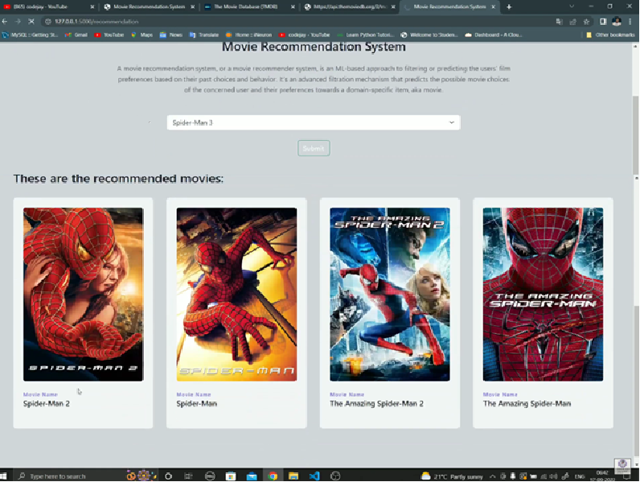

In First Test Case, user search the movie according to his interest and website recommended the similar movies that the user search.

**Second User**

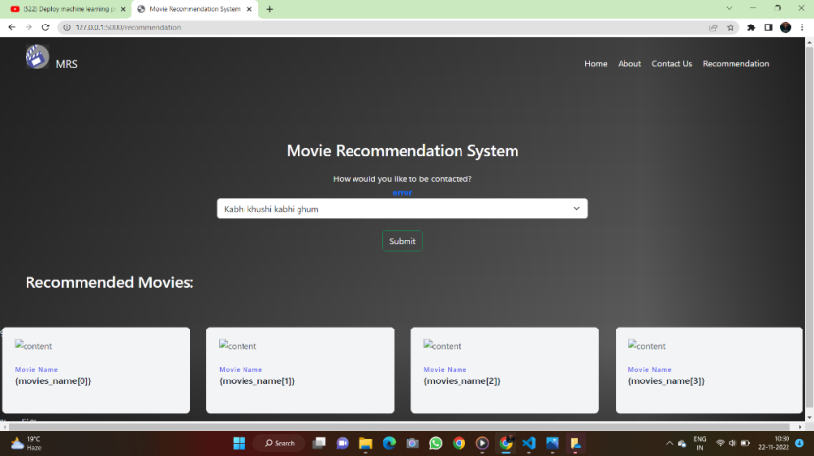

In this Test Case, User search the movie that is not belong to our dataset , so it is not recommended the movies.

**Chapter 8**

**Snapshots**

**Home Page:-**



**About:-**

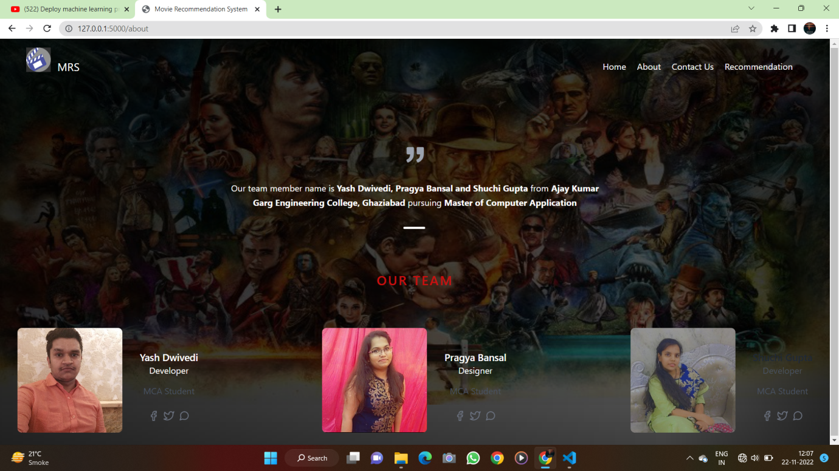

**Contact Page :-**

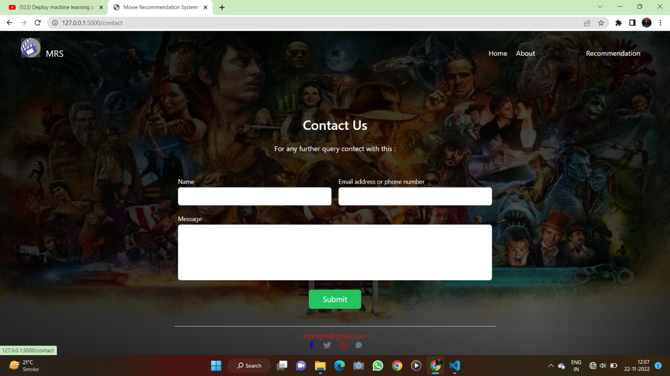

**Recommendation Page:-**

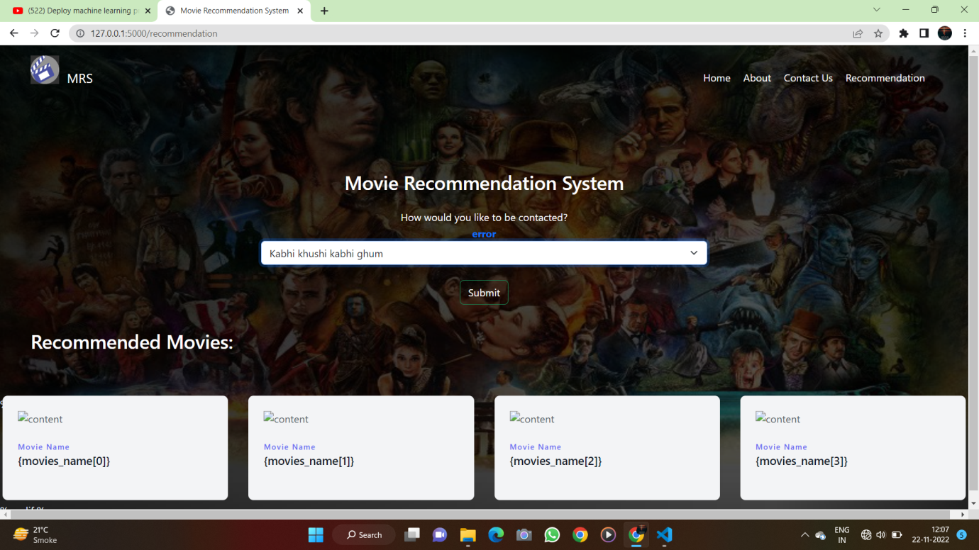

**Chapter 10**

**References:-**

* [**https://youtu.be/DeUf4-aqk9s**](https://youtu.be/DeUf4-aqk9s)
* [**https://youtu.be/7rEagFH9tQg**](https://youtu.be/7rEagFH9tQg)
* [**https://youtu.be/1xtrIEwY_zY**](https://youtu.be/1xtrIEwY_zY)